Secure Multi-Part File Transfer Application

INDEX
1. Introduction
2. System Analysis
a. Existing System
b. proposed System
3. Feasibility Report
a. Technical Feasibility
b. Operational Feasibility
c. Economical Feasibility
4. System Requirement Specification Document
a. Overview
b. Modules Description
c. Process Flow
d. SDLC Methodology
e. Software Requirements
f. Hardware Requirements

5. System Design
a. DFD
b. E-R diagram
c. UML
d. Data Dictionary
6. Technology Description
7. Coding
8. Testing & Debugging Techniques
9. Output Screens
10. Reports
11. Future Enhancements
12. Conclusion
13. Bibliography

ABSTRACT
Project name: Secure Multi-Part File Transfer
Encryption of data plays a vital role in the real time environment to keep the data out of reach of unauthorized people, such that it is not altered and tampered. But sending the large amount of data through the network is also takes lot of time. The File Splitter is software, which tries to alter the originality of the text into some encrypted form and split the encrypted file into user specified size. Then the spitted files can easily send through the network in very less time. The major task of the File splitter is to provide the user the flexibility of passing the information implementing the encryption standards as per the specification and algorithms proposed and store the information in a form that is unreadable. The Application should have a reversal process as of which should be in a position to decrypt the data to its original format upon the proper request by the user. While the Encryption and Decryption is done the application should confirm the standards of authentication and authorization of the user. Before decrypting the file the user has to merge the files.

We need to design software, which provides the users with the flexibility of sending and receiving files or messages in a secured format. This software design includes the encryption and decryption algorithms for converting the normal text to cipher text for a secured transfer and splitting the file will make the user to transfer the files very easily. File Splitter is software, which is used to split the user-specifying file according to the user specifying size. It is very difficult to transfer one big file from one end to another through any media like Internet or small storage like Floppy, Pen drive etc.

Introduction :
Encryption of data plays a vital role in the real time environment to keep the data out of reach of unauthorized people, such that it is not altered and tampered and sending the in splitter format is most secured way to transfer the data through the network. The File Splitter is software, which tries to alter the originality of the file into some encrypted form and split the file into user specified size. Then the users can easily and securely carry the data where ever he wants. The major task of the File splitter is to provide the user the flexibility of passing the information implementing the encryption standards as per the specification and algorithms proposed and store the information in a form that is unreadable. The Application should have a reversal process as of which should be in a position to merge the splitted files and decrypt the data to its original format upon the proper request by the user. While the Encryption and Decryption is done the application should confirm the standards of authentication and authorization of the user.
The Entire application should strive to achieve a user friendly Graphical User Interface, which need to be in a self-learning mode for the end user. The System should provide all the functional standards of proper navigation with in the environment, which makes it possible for the users to have a smooth flow while working under the environment. The Overall system should provide proper menu based navigation for easier navigation and operation. The Application should be designed in such a way that, as soon as it starts create a Buffer and associate this buffer to some homogeneous data environment, the application should ask the user for the Encryption Key details and should start its functionality upon the logistics that are provided with in this key. The key should be designed in such a way that it prevents the unauthorized persons from stealing the information at any point of time.
The application of Merging and Decryption should be a reverse process at the other end and should be translated only when the receiver of the data applies the proper reversal key. The Decryption process should have a log-based methodology that will take care of any errors that may be encountered while the system is under utilization and should record all those events, which are above the general standards of security.
SYSTEM ANALYSIS
Existing System
In the traditional architecture there existed only the server and the client. In most cases the server was only a data base server that can only offer data. Therefore majority of the business logic i.e., validations etc. had to be placed on the clients system. This makes maintenance expensive. Such clients are called as ‘fat clients’. This also means that every client has to be trained as to how to use the application and even the security in the communication is also the factor to be considered.
Since the actual processing of the data takes place on the remote client the data has to be transported over the network, which requires a secured format of the transfer method. How to conduct transactions is to be controlled by the client and advanced techniques implementing the cryptographic standards in the executing the data transfer transactions. Present day transactions are considered to be "un-trusted" in terms of security, i.e. they are relatively easy to be hacked. And also we have to consider the transfer the large amount of data through the network will give errors while transferring. Nevertheless, sensitive data transfer is to be carried out even if there is lack of an alternative. Network security in the existing system is the motivation factor for a new system with higher-level security standards for the information exchange.

Proposed System
The proposed system should have the following features. The transactions should take place in a secured format between various clients in the network. It provides flexibility to the user to transfer the data through the network very easily by splitting the large amount of file in to user specified size. It should also identify the user and provide the communication according to the prescribed level of security with transfer of the file requested and run the required process at the server if necessary. When responding to the client, the server should send necessary information such as User authorization and authentication information, Merging, Encryption, Decryption types and their level of hierarchy etc.
FEASIBILITY REPORT

Fact Finding Techniques
In this system we are going to develop a facility to a user that he will not face any difficulty at the time of usage like data missing, one way contacts, one view contacts. As we are developing this system with an encoding technique of images the user will not be bothered on which camera support is using, as well in sound. As we are maintaining one technique of speed controlling the frame relay will not be a problem for the user like over speed display, hanged display.

Feasibility Study
A feasibility study is a high-level capsule version of the entire System analysis and Design Process. The study begins by classifying the problem definition. Feasibility is to determine if it’s worth doing. Once an acceptance problem definition has been generated, the analyst develops a logical model of the system. A search for alternatives is analyzed carefully. There are 3 parts in feasibility study.

Operational Feasibility:
Question that going to be asked are
- Will the system be used if it developed and implemented.
- If there was sufficient support for the project from the management and from the users.
- Have the users been involved in planning and development of the
Project.
- Will the system produce poorer result in any respect or area?
This system can be implemented in the organization because there is adequate support from management and users. Being developed in Java so that the necessary operations are carried out automatically.

Technical feasibility
- Does the necessary technology exist to do what is been suggested
- Does the proposed equipment have the technical capacity for using the new system?
- Are there technical guarantees of accuracy, reliability and data security?
- The project is developed on Pentium IV with 256 MB RAM.
- The environment required in the development of system is any windows platform
- The observer pattern along with factory pattern will update the results eventually
- The language used in the development is JAVA 1.5 & Windows Environment

Financial and Economical Feasibility:
The system developed and installed will be good benefit to the organization. The system will be developed and operated in the existing hardware and software infrastructure. So there is no need of additional hardware and software for the system.

SYSTEM REQUIREMENT SPECIFICATION

System Analysis
People for long time have tried to sort out the problems faced in the general Tiny communication system but as these problems exist even now, a secured and easy transfer system evolved and came to be known as the Encryption and Decryption of the data to be transferred using the cryptographic standards. The advantages of this File Splitter are:
- High level Security
- Cost effective transfer
In this fast growing world where every individual free to access the information on the network and even the people are technically sound enough in hacking the information from the network for various reasons. The organizations have the process of information transfer in and out of their network at various levels, which need the process to be in a secured format for the organizational benefits.
If the organizations have the File Splitter System, then each employee can send the information to any other registered employee and thus can establish communication and perform the prescribed tasks in secured fashion. The splitted files that the employee sends reaches the destination within no time in an encrypted format where the end user need to merge the splitted files and decrypt it and use for the purpose. The various branches of the organization can be connected to a single host server and then an employee of one branch can send files to the employee of another branch through the server but in a secured format.

System Design
The System Design includes the maintenance of the secure file transfer service with a prescribed encryption format and split at the interested level of encryption and the receiving service at the other end with merging and decryption process. The design also includes the provision of facility to the user to manipulate the concerned information according to his personal use and communication process.
The design also needs to provide the communication channel to the user to communicate with other registered users through the mailing services in a reliable and secured format. Authorization and authentication services are preferred most for this purpose. The System Design includes the maintenance authorization services, File and directory services with a prescribed encryption format at the interested level of encryption and the receiving service at the other end with decryption process. The design also includes the provision of facility to the user to manipulate the concerned information according to his personal use.
The design of File Splitter system, basically involve the interface architecture, authorization and authentication system, Security services, and communication system.
In the interface design we involve with the design of the user interface with GUI standards and a proper navigation system where the user need to enter into the flow of transactions authorization services are check and further access is provided into the system. Then the user needs to select into the operations provided through the GUI where encryption, splitting, Merging, Decryption and sending of the file, General information and exit are provided.
Here the Encryption and decryption and services are provided connecting to the security services module where the encryption and decryption are carried out using the Tiny Encryption Standards implementing the Tiny Encryption algorithm.
After the encryption of the file is completed the user is to select the file for splitting it to user specified size and sending through the network to the desired user by specifying the targeted users system IP address in the panel designed. Then the system gets connected to the targeted user and delivers the file in cipher format after which the user working with the File Splitter System software should go for the option Merge Files and decrypt the file by selecting the file path by which the file gets decrypted and is viewed on the system.

Modules:
- GUI Module
- Encrypt and Decrypt Module(Tiny encryption)
- Send and Receive Module.

GUI Module:
GUI Module basically deals with the design of the interface which include the service of providing the user with the flexibility of accessing the file system and selecting the required file for the transfer. It should also provide the system to collect the information from the user to check the authorization in providing the access to the file system. The interface is also to consider the design, which include the services of sending and receiving of the files with encryption and decryption standards.
Encryption and Decryption Module (Tiny encryption):
The Tiny Encryption Algorithm (TEA) is a cryptographic algorithm designed to minimize memory footprint and maximize speed. It is a Feistel type cipher that uses operations from mixed (orthogonal) algebraic groups. This research presents the cryptanalysis of the Tiny Encryption Algorithm. In this research we inspected the most common methods in the cryptanalysis of a block cipher algorithm. TEA seems to be highly resistant to differential cryptanalysis, and achieves complete diffusion (where a one bit difference in the plaintext will cause approximately 32 bit differences in the cipher text) after only six rounds. Time performance on a modern desktop computer or workstation is very impressive.
As computer systems become more pervasive and complex, security is increasingly important. Cryptographic algorithms and protocols constitute the central component of systems that protect network transmissions and store data. The security of such systems greatly depends on the methods used to manage, establish, and distribute the keys employed by the cryptographic techniques. Even if a cryptographic algorithm is ideal in both theory and implementation, the strength of the algorithm will be rendered useless if the relevant keys are poorly managed.
The following notation is necessary for our discussion.
• Hexadecimal numbers will be subscripted with “h,” e.g., 10 = 16. h
Bitwise Shifts: The logical shift of x by y bits is denoted by x << y. The logical right shift of x by y bits is denoted by x >> y.
Bitwise Rotations: A left rotation of x by y bits is denoted by x <<< y. A right rotation of x by y bits is denoted by x >>> y.
Exclusive-OR: The operation of addition of n-tuples over the field (also known as 2F exclusive-or) is denoted by x⊕y.
The Tiny Encryption Algorithm is a Feistel type cipher that uses operations from mixed (orthogonal) algebraic groups. A dual shift causes all bits of the data and key to be mixed repeatedly. The key schedule algorithm is simple; the 128-bit key K is split into four 32-bit blocks K = (K [0], K [1], K [2], K [3]). TEA seems to be highly resistant to differential cryptanalysis and achieves complete diffusion (where a one bit difference in the plaintext will cause approximately 32 bit differences in the cipher text). Time performance on a workstation is very impressive.
Block ciphers where the cipher text is calculated from the plain text by repeated application of the same transformation or round function. In a Feistel cipher, the text being encrypted is split into two halves. The round function, F, is applied to one half using a sub key and the output of F is (exclusive-or-ed (XORed)) with the other half. The two halves are then swapped. Each round follows the same pattern except for the last round where there is often no swap. The focus of this thesis is the TEA Feistel Cipher.
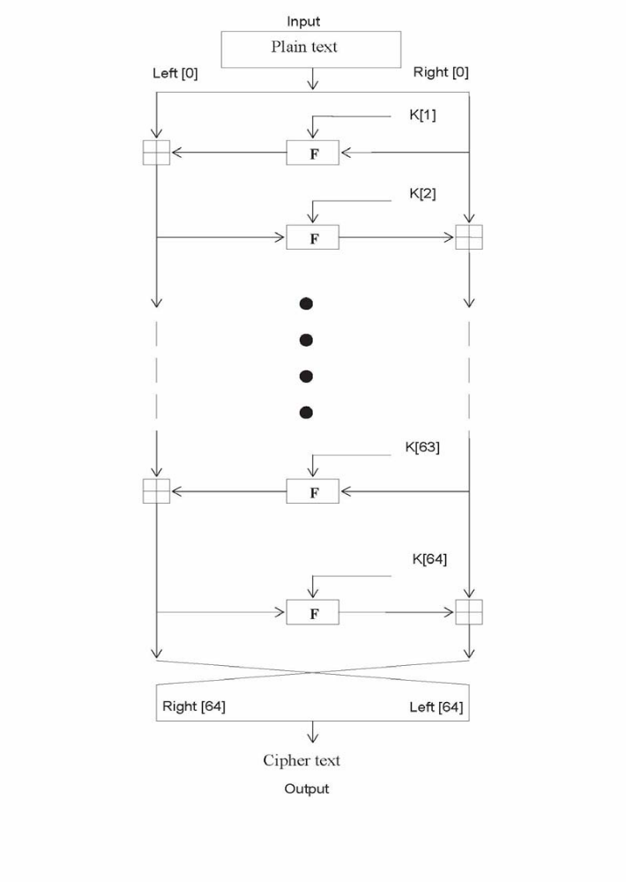
The inputs to the encryption algorithm are a plaintext block and a key K .The plaintext is P = (Left[0], Right[0]) and the cipher text is C = (Left[64], Right[64]). The plaintext block is split into two halves, Left[0] and Right[0]. Each half is used to encrypt the other half over 64 rounds of processing and then combine to produce the cipher text block.
• Each round i has inputs Left[i-1] and Right[i-1], derived from the previous round, as well as a sub key K[i] derived from the 128 bit overall K.
• The sub keys K[i] are different from K and from each other.
• The constant delta =(5^{1/2}-1)*2³¹ =9E3779B h , is derived from the golden number ratio to ensure that the sub keys are distinct and its precise value has no cryptographic significance.
• The round function differs slightly from a classical Fiestel cipher structure in that integer addition modulo 2³² is used instead of exclusive-or as the combining operator.

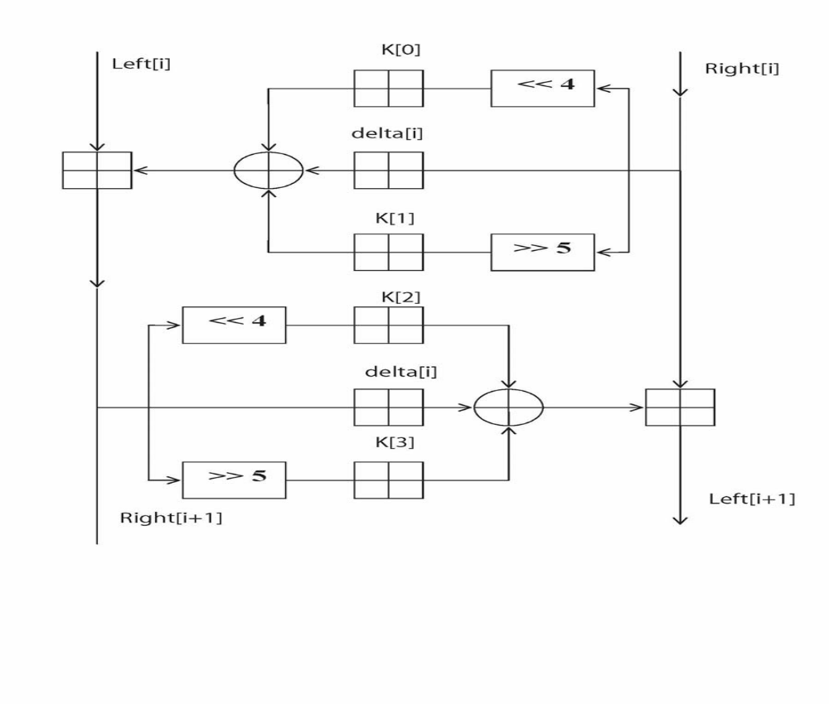

Above Figure presents the internal details of the ith cycle of TEA. The round function, F, consists of the key addition, bitwise XOR and left and right shift operation. We can describe the output (Left[i +1] , Right[i +1] ) of the ith cycle of TEA with the input (Left[i] ,Right[i] ) as follows
Left [i+1] = Left[i] F ( Right[i], K [0, 1], delta[i] ),
Right [i +1] = Right[i] F ( Right[i +1], K [2, 3], delta[i] ),
delta[i] = (i +1)/2 * delta,
The round function, F, is defined by
F(M, K[j,k], delta[i] ) = ((M << 4) K[j]) ⊕ (M delta[i] ) ⊕ ((M >> 5) K[k]).
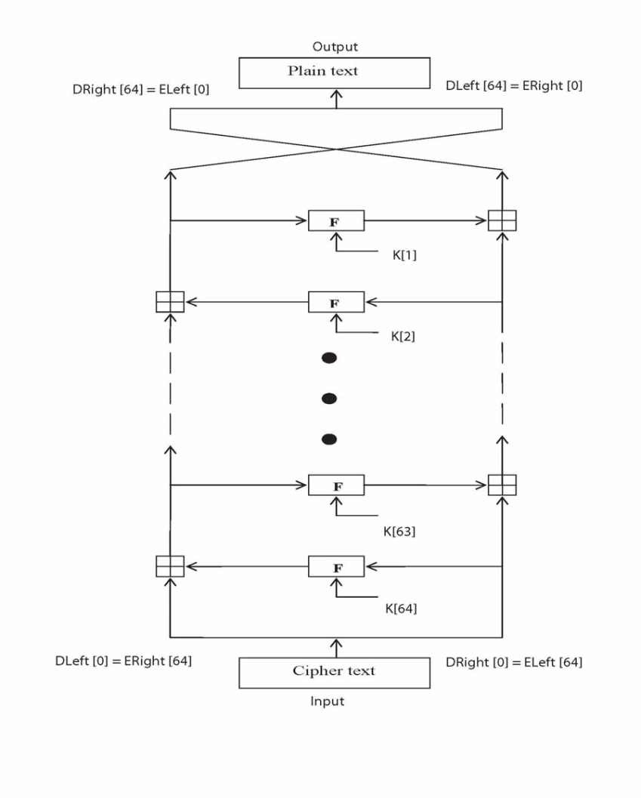
The round function has the same general structure for each round but is parameterized by the round sub key K[i]. The key schedule algorithm is simple; the 128-bit key K is split into four 32-bit blocks K = ( K[0], K[1], K[2], K[3]). The keys K[0] and K[1] are used in the odd rounds and the keys K[2] and K[3] are used in even rounds.

Decryption is essentially the same as the encryption process; in the decode routine the cipher text is used as input to the algorithm, but the sub keys K[i] are used in the reverse order.
Figure presents the structure of the TEA decryption routine. The intermediate value of the decryption process is equal to the corresponding value of the encryption process with the two halves of the value swapped. For example, if the output of the nth encryption round is
ELeft[i] || ERight[i] (ELeft[i] concatenated with ERight[i]).
Then the corresponding input to the (64-i)th decryption round is
DRight[i] || DLeft[i] (DRight[i] concatenated with DLeft[i]).
After the last iteration of the encryption process, the two halves of the output are swapped, so that the cipher text is ERight[64] || ELeft[64], the output of that round is the final cipher text C. Now this cipher text is used as the input to the decryption algorithm. The input to the first round is ERight[64] || ELeft[64], which is equal to the 32-bit swap of the output of the 64th round of the encryption process.

SDLC METHDOLOGIES

SDLC METHDOLOGIES
This document play a vital role in the development of life cycle (SDLC) as it describes the complete requirement of the system. It means for use by developers and will be the basic during testing phase. Any changes made to the requirements in the future will have to go through formal change approval process.
SPIRAL MODEL was defined by Barry Boehm in his 1988 article, “A spiral Model of Software Development and Enhancement. This model was not the first model to discuss iterative development, but it was the first model to explain why the iteration models.
As originally envisioned, the iterations were typically 6 months to 2 years long. Each phase starts with a design goal and ends with a client reviewing the progress thus far. Analysis and engineering efforts are applied at each phase of the project, with an eye toward the end goal of the project.
The steps for Spiral Model can be generalized as follows:
- The new system requirements are defined in as much details as possible. This usually involves interviewing a number of users representing all the external or internal users and other aspects of the existing system.
- A preliminary design is created for the new system.
- A first prototype of the new system is constructed from the preliminary design. This is usually a scaled-down system, and represents an approximation of the characteristics of the final product.
- A second prototype is evolved by a fourfold procedure:
- Evaluating the first prototype in terms of its strengths, weakness, and risks.
- Defining the requirements of the second prototype.
- Planning an designing the second prototype.
- Constructing and testing the second prototype.
- At the customer option, the entire project can be aborted if the risk is deemed too great. Risk factors might involved development cost overruns, operating-cost miscalculation, or any other factor that could, in the customer’s judgment, result in a less-than-satisfactory final product.
- The existing prototype is evaluated in the same manner as was the previous prototype, and if necessary, another prototype is developed from it according to the fourfold procedure outlined above.
- The preceding steps are iterated until the customer is satisfied that the refined prototype represents the final product desired.
- The final system is constructed, based on the refined prototype.
- The final system is thoroughly evaluated and tested. Routine maintenance is carried on a continuing basis to prevent large scale failures and to minimize down time.

The following diagram shows how a spiral model acts like:

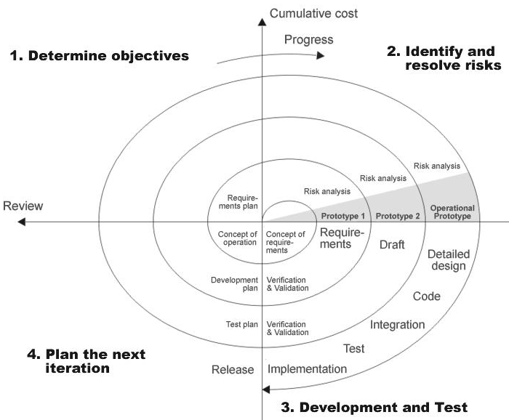

Fig 1.0-Spiral Model
ADVANTAGES:
- Estimates(i.e. budget, schedule etc .) become more relistic as work progresses, because important issues discoved earlier.
- It is more able to cope with the changes that are software development generally entails.
- Software engineers can get their hands in and start woring on the core of a project earlier.

APPLICATION DEVELOPMENT
N-TIER APPLICATIONS
N-Tier Applications can easily implement the concepts of Distributed Application Design and Architecture. The N-Tier Applications provide strategic benefits to Enterprise Solutions. While 2-tier, client-server can help us create quick and easy solutions and may be used for Rapid Prototyping, they can easily become a maintenance and security night mare
The N-tier Applications provide specific advantages that are vital to the business continuity of the enterprise. Typical features of a real life n-tier may include the following:
- Security
- Availability and Scalability
- Manageability
- Easy Maintenance
- Data Abstraction
The above mentioned points are some of the key design goals of a successful n-tier application that intends to provide a good Business Solution.

DEFINITION
Simply stated, an n-tier application helps us distribute the overall functionality into various tiers or layers:
- Presentation Layer
- Business Rules Layer
- Data Access Layer
- Database/Data Store
Each layer can be developed independently of the other provided that it adheres to the standards and communicates with the other layers as per the specifications.
This is the one of the biggest advantages of the n-tier application. Each layer can potentially treat the other layer as a ‘Block-Box’.
In other words, each layer does not care how other layer processes the data as long as it sends the right data in a correct format.
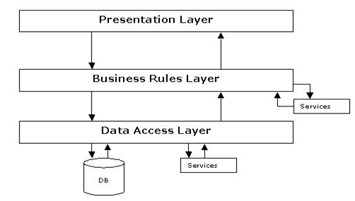
Fig 1.1-N-Tier Architecture
- THE PRESENTATION LAYER
Also called as the client layer comprises of components that are dedicated to presenting the data to the user. For example: Windows/Web Forms and buttons, edit boxes, Text boxes, labels, grids, etc.
- THE BUSINESS RULES LAYER
This layer encapsulates the Business rules or the business logic of the encapsulations. To have a separate layer for business logic is of a great advantage. This is because any changes in Business Rules can be easily handled in this layer. As long as the interface between the layers remains the same, any changes to the functionality/processing logic in this layer can be made without impacting the others. A lot of client-server apps failed to implement successfully as changing the business logic was a painful process.
- THE DATA ACCESS LAYER
This layer comprises of components that help in accessing the Database. If used in the right way, this layer provides a level of abstraction for the database structures. Simply put changes made to the database, tables, etc do not affect the rest of the application because of the Data Access layer. The different application layers send the data requests to this layer and receive the response from this layer.
- THE DATABASE LAYER
This layer comprises of the Database Components such as DB Files, Tables, Views, etc. The Actual database could be created using SQL Server, Oracle, Flat files, etc.
In an n-tier application, the entire application can be implemented in such a way that it is independent of the actual Database. For instance, you could change the Database Location with minimal changes to Data Access Layer. The rest of the Application should remain unaffected.

SOFTWARE REQUIREMENT

System Configuration

Software Requirements:
- Operating System
Windows NT/2000 (Client/Server).
- Software requirements
Front-end: Java J2SDK 1.5, Swings.

HARDWARE REQUIREMENT

Hardware Requirements:
- System Configuration
Pentium III Processor with 700 MHz Clock Speed
256 MB RAM 20 GB HDD, 32 Bit PCI Ethernet Card.

SYSTEM DESIGN

PROCESS FLOW

DATA FLOW DIAGRAMS

DATA FLOW DIAGRAMS:
A graphical tool used to describe and analyze the moment of data through a system manual or automated including the process, stores of data, and delays in the system. Data Flow Diagrams are the central tool and the basis from which other components are developed. The transformation of data from input to output, through processes, may be described logically and independently of the physical components associated with the system. The DFD is also know as a data flow graph or a bubble chart.
DFDs are the model of the proposed system. They clearly should show the requirements on which the new system should be built. Later during design activity this is taken as the basis for drawing the system’s structure charts. The Basic Notation used to create a DFD’s are as follows:
1. Dataflow: Data move in a specific direction from an origin to a destination.

2. Process: People, procedures, or devices that use or produce (Transform) Data. The physical component is not identified.

3. Source: External sources or destination of data, which may be People, programs, organizations or other entities.

4. Data Store: Here data are stored or referenced by a process in the System.

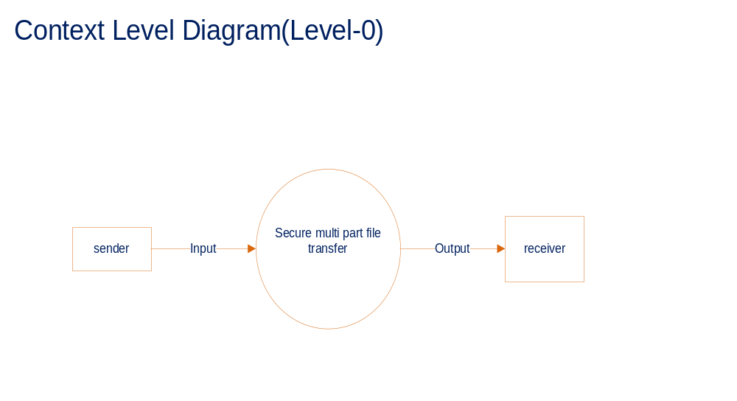Sender:
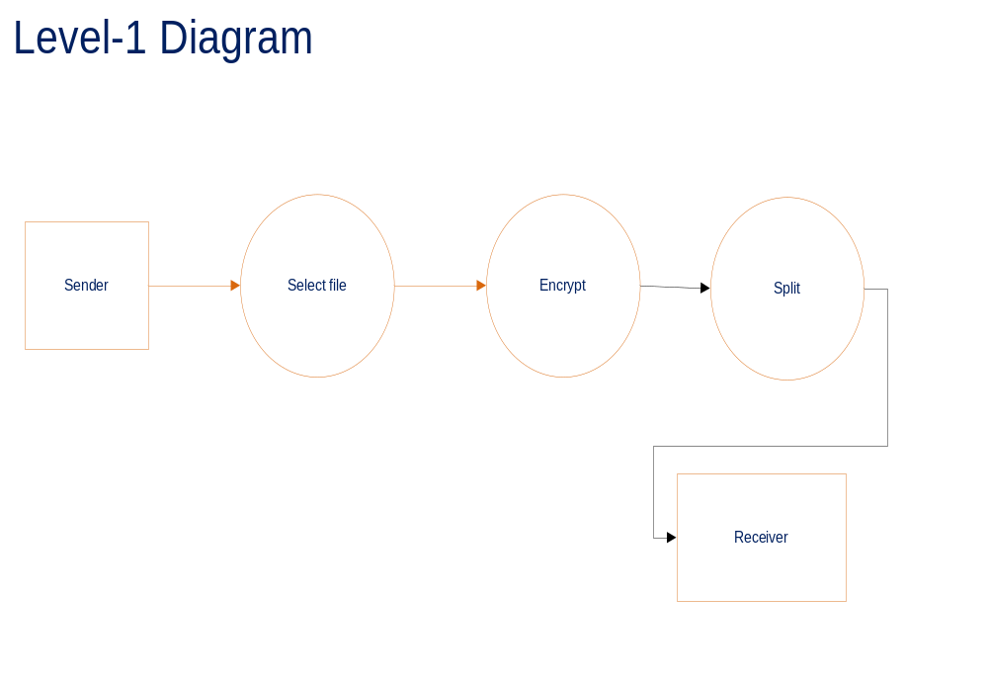

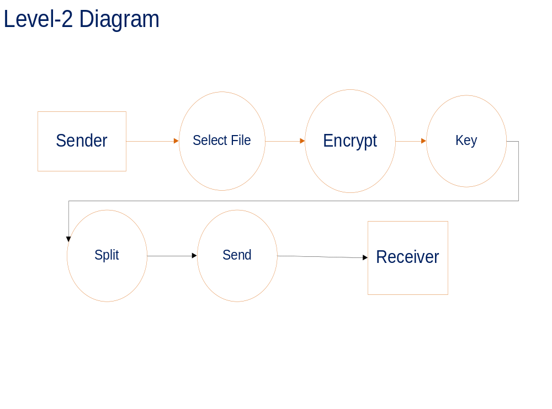

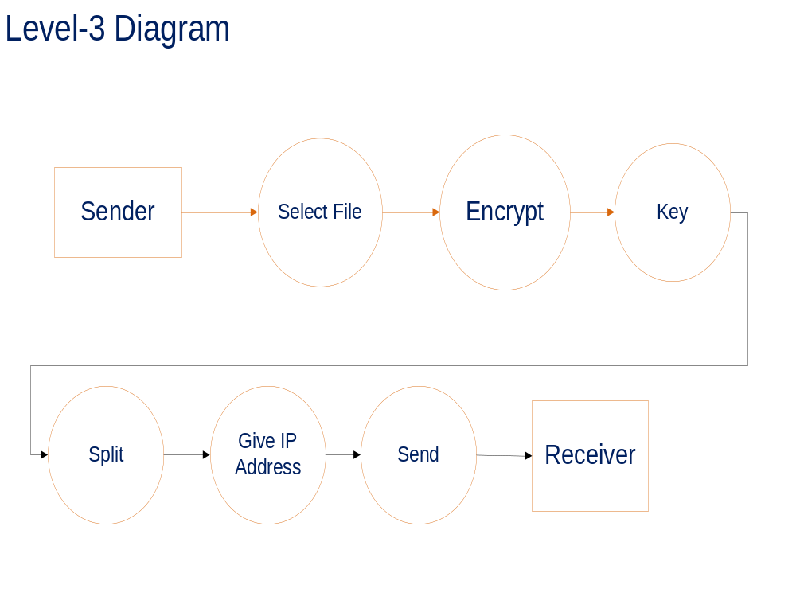

Receiver:
EMBED Visio.Drawing.11 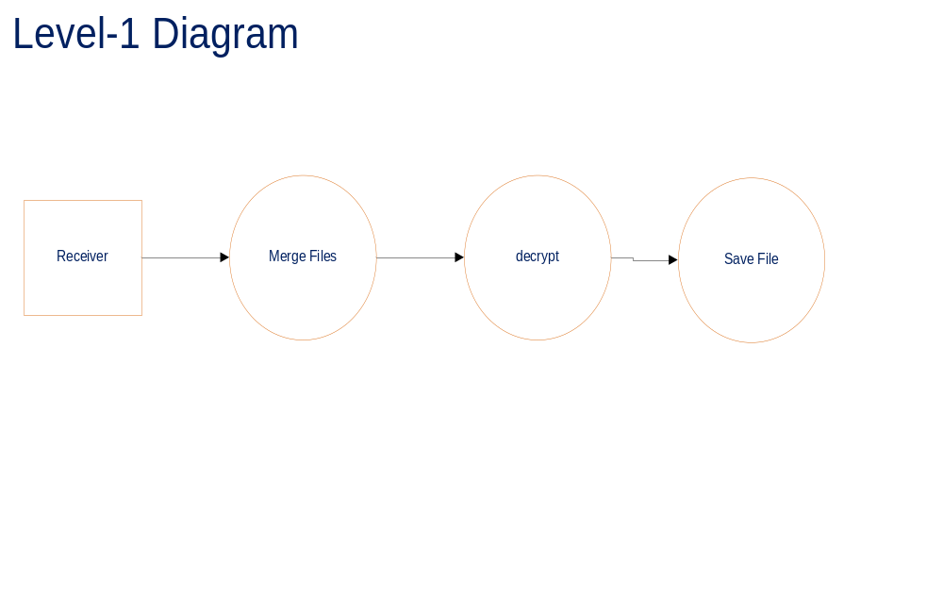
EMBED Visio.Drawing.11 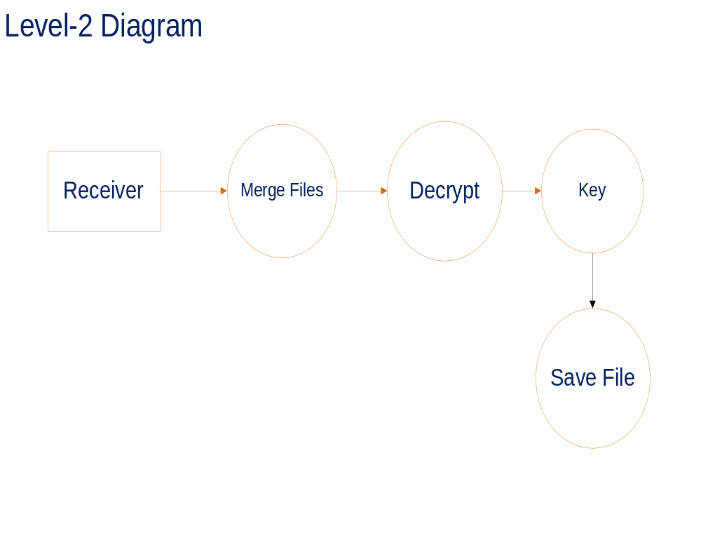

ER Diagram:
Actors are external entities that interact with the system. Examples of actors include users like administrator, bank customer …etc., or another system like central database.

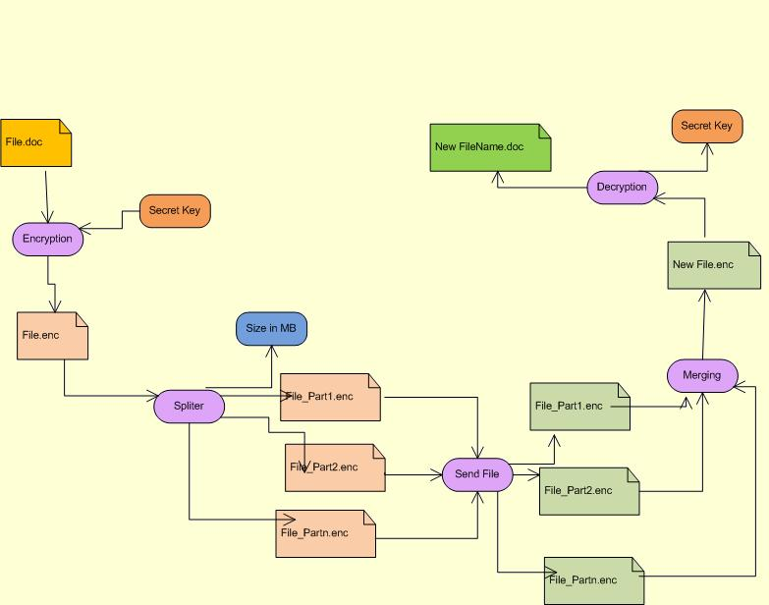
UML Diagrams
Unified Modeling Language:

The Unified Modeling Language allows the software engineer to express an analysis model using the modeling notation that is governed by a set of syntactic semantic and pragmatic rules.

A UML system is represented using five different views that describe the system from distinctly different perspective. Each view is defined by a set of diagram, which is as follows.
  - User Model View
    - This view represents the system from the users perspective.
    - The analysis representation describes a usage scenario from the end-users perspective.

  - Structural model view
    - In this model the data and functionality are arrived from inside the system.
    - This model view models the static structures.

- Behavioral Model View
It represents the dynamic of behavioral as parts of the system, depicting the interactions of collection between various structural elements described in the user model and structural model view.

- Implementation Model View
In this the structural and behavioral as parts of the system are represented as they are to be built.

- Environmental Model View
In this the structural and behavioral aspects of the environment in which the system is to be implemented are represented.

UML is specifically constructed through two different domains they are:
- UML Analysis modeling, this focuses on the user model and structural model views of the system.
- UML design modeling, which focuses on the behavioral modeling, implementation modeling and environmental model views.

Use case Diagrams represent the functionality of the system from a user’s point of view. Use cases are used during requirements elicitation and analysis to represent the functionality of the system. Use cases focus on the behavior of the system from external point of view.

Use case Diagram
Sender:
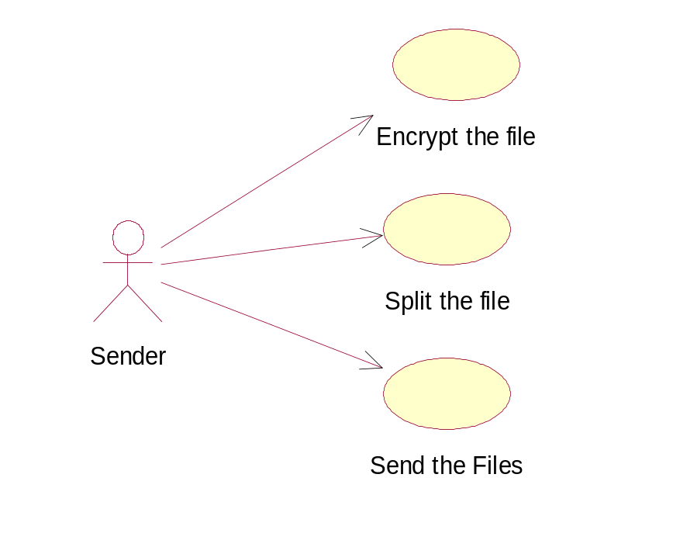
Receiver:

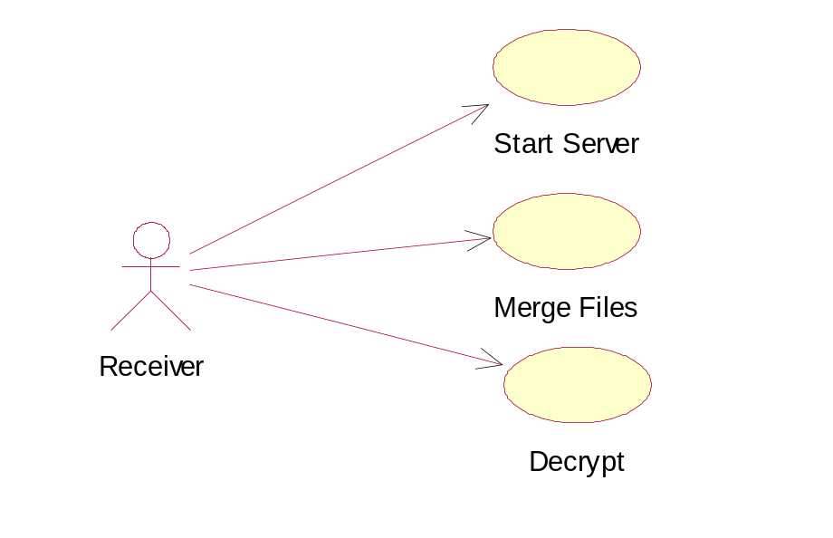

Class Diagram:
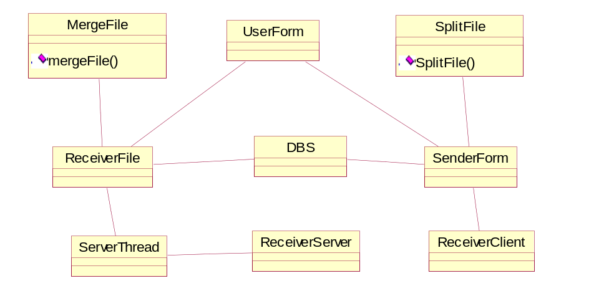

Sequence Diagrams
Sender
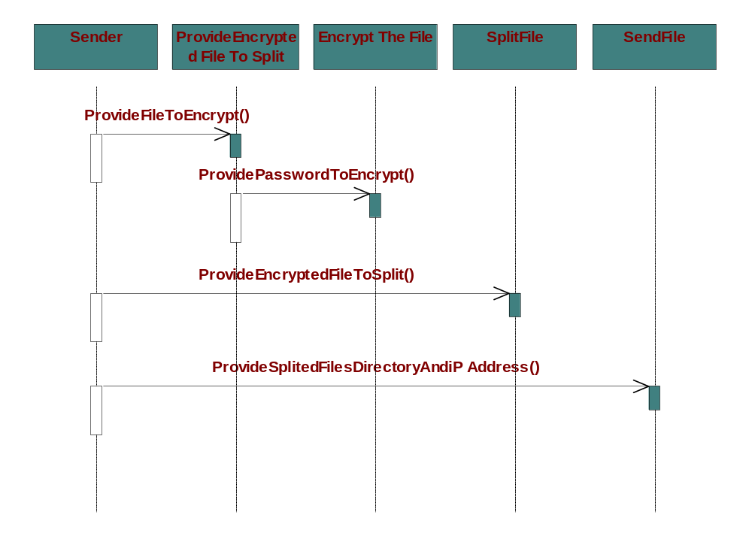

Receiver:
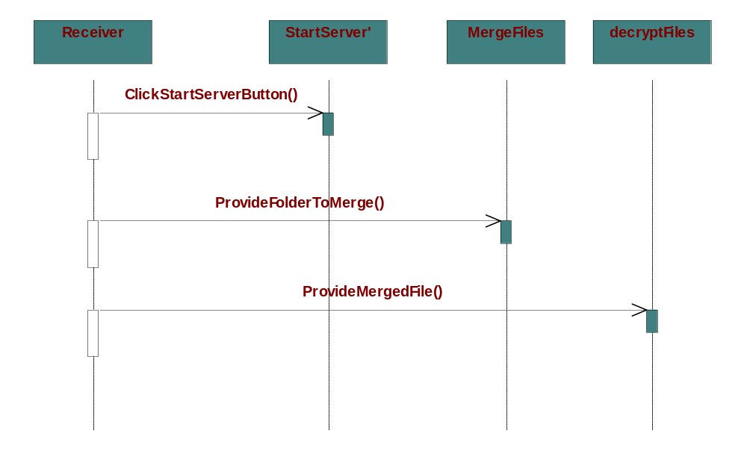

Collaboration Diagram:
Sender:
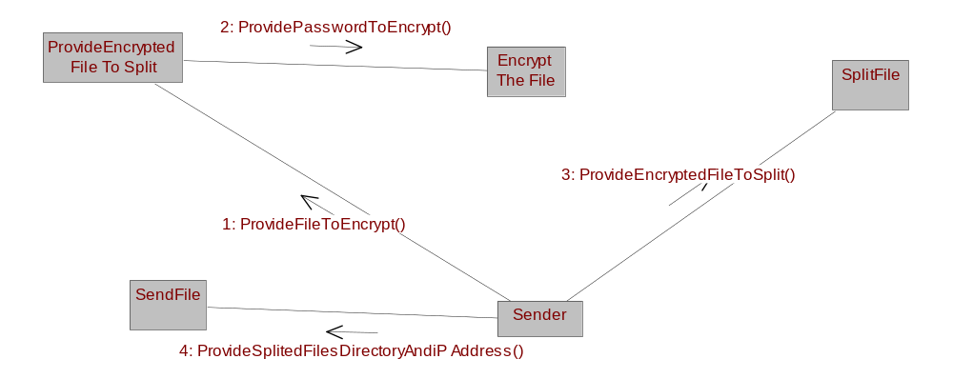

Receiver:
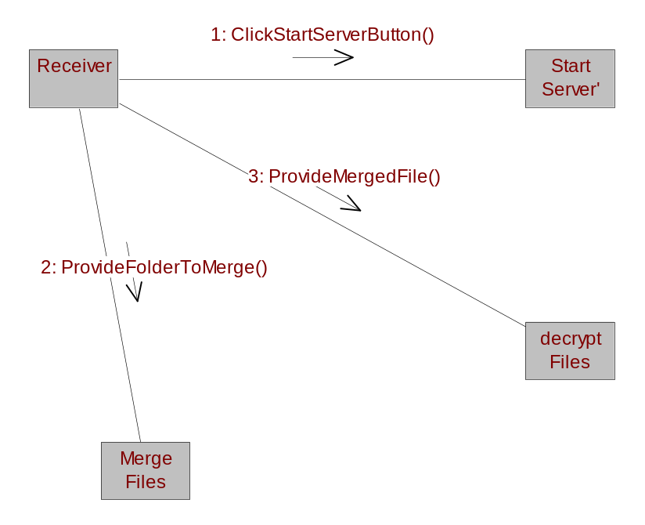

Decryption System
Receiver
Activity Diagram for Merging & Decryption

Select the Folder
Search for the file
Not found

Supply Encryption
Apply Merging
Select the Saving
Option
Save with Alternative name
Select file name
Not found
Search for the Encrypted File

Supply Encryption
Apply Decryption with Key
Select the Saving
Option

Save with Alternative name
Deployment Diagram
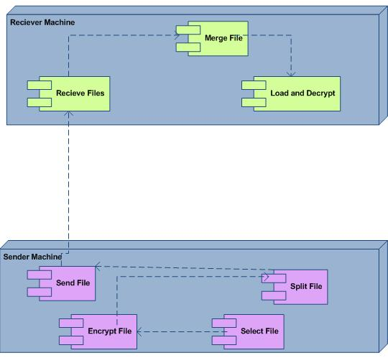
Component Diagram:
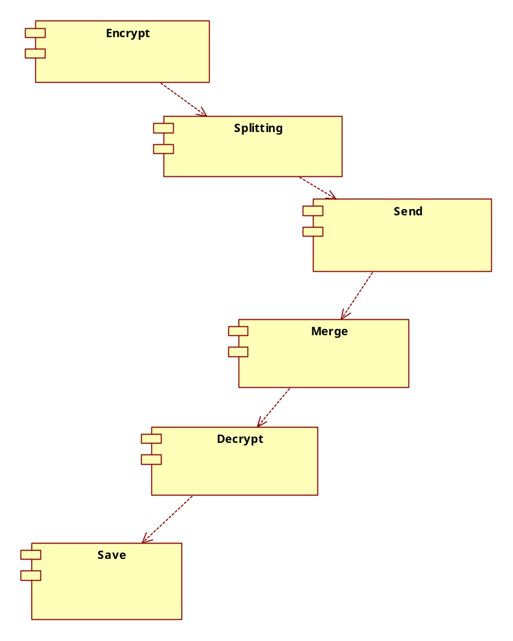

TECHNOLOGY DESCRIPTION

FEATURES OF THE LANGUAGE USED:

About Java:
Initially the language was called as “oak” but it was renamed as “Java” in 1995. The primary motivation of this language was the need for a platform-independent (i.e., architecture neutral) language that could be used to create software to be embedded in various consumer electronic devices.
- Java is a programmer’s language.
- Java is cohesive and consistent.
- Except for those constraints imposed by the Internet environment, Java gives the programmer, full control.
Finally, Java is to Internet programming where C was to system programming.
Swings:
Swing, which is an extension library to the AWT, includes new and improved components that enhance the look and functionality of GUIs. Swing can be used to build Standalone swing Gui Apps as well as Servlets and Applets. It employs a model/view design architecture. Swing is more portable and more flexible than AWT.
Swing is built on top of AWT and is entirely written in Java, using AWT’s lightweight component support. In particular, unlike AWT, t he architecture of Swing components makes it easy to customize both their appearance and behavior. Components from AWT and Swing can be mixed, allowing you to add Swing support to existing AWT-based programs. For example, swing components such as JSlider, JButton and JCheckbox could be used in the same program with standard AWT labels, textfields and scrollbars. You could subclass the existing Swing UI, model, or change listener classes without having to reinvent the entire implementation. Swing also has the ability to replace these objects on-the-fly.
- 100% Java implementation of components
- Pluggable Look & Feel
- Lightweight components
- Uses MVC Architecture
Model represents the data
View as a visual representation of the data
Controller takes input and translates it to changes in data
- Three parts
Component set (subclasses of JComponent)
Support classes
Interfaces
In Swing, classes that represent GUI components have names beginning with the letter J. Some examples are JButton, JLabel, and JSlider. Altogether there are more than 250 new classes and 75 interfaces in Swing — twice as many as in AWT.
Java Swing class hierarchy
The class JComponent, descended directly from Container, is the root class for most of Swing’s user interface components.
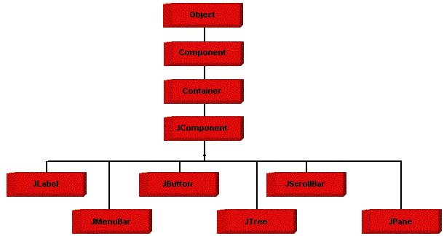
Swing contains components that you’ll use to build a GUI. I am listing you some of the commonly used Swing components. To learn and understand these swing programs, AWT Programming knowledge is not required.

Applications and Applets
An application is a program that runs on our Computer under the operating system of that computer. It is more or less like one creating using C or C++. Java’s ability to create Applets makes it important. An Applet is an application designed, to be transmitted over the Internet and executed by a Java –compatible web browser. An applet is actually a tiny Java program, dynamically downloaded across the network, just like an image. But the difference is, it is an intelligent program, not just a media file. It can react to the user input and dynamically change.

FEATURES OF JAVA:

Security
Every time you that you download a “normal” program, you are risking a viral infection. Prior to Java, most users did not download executable programs frequently, and those who did scanned them for viruses prior to execution. Most users still worried about the possibility of infecting their systems with a virus. In addition, another type of malicious program exists that must be guarded against. This type of program can gather private information, such as credit card numbers, bank account balances, and passwords. Java answers both of these concerns by providing a “firewall” between a networked application and your computer. When you use a Java-compatible Web browser, you can safely download Java applets without fear of virus infection or malicious intent.

Portability
For programs to be dynamically downloaded to all the various types of platforms connected to the Internet, some means of generating portable executable code is needed .As you will see, the same mechanism that helps ensure security also helps create portability. Indeed, Java’s solution to these two problems is both elegant and efficient.

The Byte code
The key that allows the Java to solve the security and portability problem is that the output of Java compiler is Byte code. Byte code is a highly optimized set of instructions designed to execute by the Java run-time system, which is called the Java Virtual Machine (JVM). That is, in its standard form, the JVM is an interpreter for byte code.
Translating a Java program into byte code helps makes it much easier to run a program in a wide variety of environments. The reason is, once the runtime package exists for a given system,any Java program can run on it.
Although Java was designed for interpretation, there is technically nothing about Java that prevents on-the-fly compilation of byte code into native code. Sun has just completed its Just In Time (JIT) compiler for byte code. When the JIT compiler is a part of JVM, it compiles byte code into executable code in real time, on a piece-by-piece, demand basis. It is not possible to compile an entire Java program into executable code all at once, because Java performs various run-time checks that can be done only at run time. The JIT compiles code, as it is needed, during execution.
Java Virtual Machine (JVM)
Beyond the language, there is the Java virtual machine. The Java virtual machine is an important element of the Java technology. The virtual machine can be embedded within a web browser or an operating system. Once a piece of Java code is loaded onto a machine, it is verified. As part of the loading process, a class loader is invoked and does byte code verification makes sure that the code that’s has been generated by the compiler will not corrupt the machine that it’s loaded on. Byte code verification takes place at the end of the compilation process to make sure that is all accurate and correct. So byte code verification is integral to the compiling and executing of Java code.

Java Source

Java byte code
Javac

Java Virtual

Machine

.Java .Class

The above picture shows the development process a typical Java programming uses to produce byte codes and executes them. The first box indicates that the Java source code is located in a. Java file that is processed with a Java compiler called JAVA. The Java compiler produces a file called a. class file, which contains the byte code. The class file is then loaded across the network or loaded locally on your machine into the execution environment is the Java virtual machine, which interprets and executes the byte code.

Java Architecture
Java architecture provides a portable, robust, high performing environment for development. Java provides portability by compiling the byte codes for the Java Virtual Machine, which is then interpreted on each platform by the run-time environment. Java is a dynamic system, able to load code when needed from a machine in the same room or across the planet.

Compilation of Code
When you compile the code, the Java compiler creates machine code (called byte code) for a hypothetical machine called Java Virtual Machine (JVM). The JVM is supposed to execute the byte code. The JVM is created for overcoming the issue of portability. The code is written and compiled for one machine and interpreted on all machines. This machine is called Java Virtual Machine.
Compiling and interpreting Java Source Code

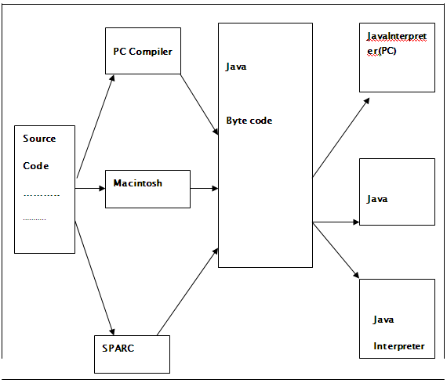
During run-time the Java interpreter tricks the byte code file into thinking that it is running on a Java Virtual Machine. In reality this could be a Intel Pentium Windows 95 or Suns ARC station running Solaris or Apple Macintosh running system and all could receive code from any computer through Internet and run the Applets.

SIMPLE
Java was designed to be easy for the Professional programmer to learn and to use effectively. If you are an experienced C++ programmer, learning Java will be even easier. Because Java inherits the C/C++ syntax and many of the object oriented features of C++. Most of the confusing concepts from C++ are either left out of Java or implemented in a cleaner, more approachable manner. In Java there are a small number of clearly defined ways to accomplish a given task.

Object-Oriented
Java was not designed to be source-code compatible with any other language. This allowed the Java team the freedom to design with a blank slate. One outcome of this was a clean usable, pragmatic approach to objects. The object model in Java is simple and easy to extend, while simple types, such as integers, are kept as high-performance non-objects.

Robust
The multi-platform environment of the Web places extraordinary demands on a program, because the program must execute reliably in a variety of systems. The ability to create robust programs was given a high priority in the design of Java. Java is strictly typed language; it checks your code at compile time and run time. Java virtually eliminates the problems of memory management and de-allocation, which is completely automatic. In a well-written Java program, all run time errors can –and should –be managed by your program.

What is networking?
Computers running on the Internet communicate to each other using either the Transmission Control Protocol (TCP) or the User Datagram Protocol (UDP), as this diagram illustrates:
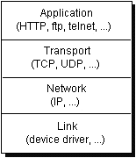
When you write Java programs that communicate over the network, you are programming at the application layer. Typically, you don't need to concern yourself with the TCP and UDP layers. Instead, you can use the classes in the java.net package. These classes provide system-independent network communication. However, to decide which Java classes your programs should use, you do need to understand how TCP and UDP differ.

TCP
When two applications want to communicate to each other reliably, they establish a connection and send data back and forth over that connection.This is analogous to making a telephone call. If you want to speak to Aunt Beatrice in Kentucky, a connection is established when you dial her phone number and she answers. You send data back and forth over the connection by speaking to one another over the phone lines. Like the phone company, TCP guarantees that data sent from one end of the connection actually gets to the other end and in the same order it was sent. Otherwise, an error is reported.
TCP provides a point-to-point channel for applications that require reliable communications. The Hypertext Transfer Protocol (HTTP), File Transfer Protocol (FTP), and Telnet are all examples of applications that require a reliable communication channel. The order in which the data is sent and received over the network is critical to the success of these applications. When HTTP is used to read from a URL, the data must be received in the order in which it was sent. Otherwise, you end up with a jumbled HTML file, a corrupt zip file, or some other invalid information.
Definition: TCP (Transmission Control Protocol) is a connection-based protocol that provides a reliable flow of data between two computers.

UDP
The UDP protocol provides for communication that is not guaranteed between two applications on the network. UDP is not connection-based like TCP. Rather, it sends independent packets of data, called datagrams, from one application to another. Sending datagrams is much like sending a letter through the postal service: The order of delivery is not important and is not guaranteed, and each message is independent of any other.
Definition: UDP (User Datagram Protocol) is a protocol that sends independent packets of data, called datagram’s, from one computer to another with no guarantees about arrival. UDP is not connection-based like TCP.
For many applications, the guarantee of reliability is critical to the success of the transfer of information from one end of the connection to the other. However, other forms of communication don't require such strict standards. In fact, they may be slowed down by the extra overhead or the reliable connection may invalidate the service altogether.
Consider, for example, a clock server that sends the current time to its client when requested to do so. If the client misses a packet, it doesn't really make sense to resend it because the time will be incorrect when the client receives it on the second try. If the client makes two requests and receives packets from the server out of order, it doesn't really matter because the client can figure out that the packets are out of order and make another request. The reliability of TCP is unnecessary in this instance because it causes performance degradation and may hinder the usefulness of the service.
Another example of a service that doesn't need the guarantee of a reliable channel is the ping command. The purpose of the ping command is to test the communication between two programs over the network. In fact, ping needs to know about dropped or out-of-order packets to determine how good or bad the connection is. A reliable channel would invalidate this service altogether.
The UDP protocol provides for communication that is not guaranteed between two applications on the network. UDP is not connection-based like TCP. Rather, it sends independent packets of data from one application to another. Sending datagrams is much like sending a letter through the mail service: The order of delivery is not important and is not guaranteed, and each message is independent of any others.
Note: Many firewalls and routers have been configured not to allow UDP packets. If you're having trouble connecting to a service outside your firewall, or if clients are having trouble connecting to your service, ask your system administrator if UDP is permitted.

Understanding Ports
Generally speaking, a computer has a single physical connection to the network. All data destined for a particular computer arrives through that connection. However, the data may be intended for different applications running on the computer. So how does the computer know to which application to forward the data? Through the use of ports.
Data transmitted over the Internet is accompanied by addressing information that identifies the computer and the port for which it is destined. The computer is identified by its 32-bit IP address, which IP uses to deliver data to the right computer on the network. Ports are identified by a 16-bit number, which TCP and UDP use to deliver the data to the right application.
In connection-based communication such as TCP, a server application binds a socket to a specific port number. This has the effect of registering the server with the system to receive all data destined for that port. A client can then rendezvous with the server at the server's port, as illustrated here:
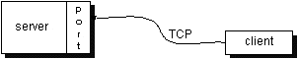
Definition: The TCP and UDP protocols use ports to map incoming data to a particular process running on a computer.
In datagram-based communication such as UDP, the datagram packet contains the port number of its destination and UDP routes the packet to the appropriate application, as illustrated in this figure:
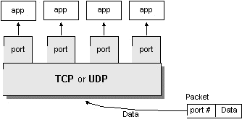
Port numbers range from 0 to 65,535 because ports are represented by 16-bit numbers. The port numbers ranging from 0 - 1023 are restricted; they are reserved for use by well-known services such as HTTP and FTP and other system services. These ports are called well-known ports. Your applications should not attempt to bind to them.

Networking Classes in the JDK
Through the classes in java.net, Java programs can use TCP or UDP to communicate over the Internet. The URL, URL Connection, Socket, and Server Socket classes all use TCP to communicate over the network. The Datagram Packet, Datagram Socket, and Multicast Socket classes are for use with UDP.

What Is a URL?
If you've been surfing the Web, you have undoubtedly heard the term URL and have used URLs to access HTML pages from the Web.
It's often easiest, although not entirely accurate, to think of a URL as the name of a file on the World Wide Web because most URLs refer to a file on some machine on the network. However, remember that URLs also can point to other resources on the network, such as database queries and command output.
Definition: URL is an acronym for Uniform Resource Locator and is a reference (an address) to a resource on the Internet.
The following is an example of a URL which addresses the Java Web site hosted by Sun Microsystems:
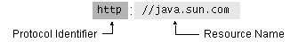
As in the previous diagram, a URL has two main components:
- Protocol identifier
- Resource name
Note that the protocol identifier and the resource name are separated by a colon and two forward slashes. The protocol identifier indicates the name of the protocol to be used to fetch the resource. The example uses the Hypertext Transfer Protocol (HTTP), which is typically used to serve up hypertext documents. HTTP is just one of many different protocols used to access different types of resources on the net. Other protocols include File Transfer Protocol (FTP), Gopher, File, and News.
The resource name is the complete address to the resource. The format of the resource name depends entirely on the protocol used, but for many protocols, including HTTP, the resource name contains one or more of the components listed in the following table:

Host Name | The name of the machine on which the resource lives.
Filename | The pathname to the file on the machine.
Port Number | The port number to which to connect (typically optional).
Reference | A reference to a named anchor within a resource that usually identifies a specific location within a file (typically optional).
For many protocols, the host name and the filename are required, while the port number and reference are optional. For example, the resource name for an HTTP URL must specify a server on the network (Host Name) and the path to the document on that machine (Filename); it also can specify a port number and a reference. In the URL for the Java Web site java.sun.com is the host name and the trailing slash is shorthand for the file named /index.html.
Sequence of socket calls for connection-oriented protocol:

System Calls
Socket - create a descriptor for use in network communication. On success, socket system call returns a small integer value similar to a file descriptor Name.

Bind - Bind a local IP address and protocol port to a socket
When a socket is created it does not have nay notion of endpoint address. An application calls bind to specify the local; endpoint address in a socket. For TCP/IP protocols, the endpoint address uses the socket address in structure. Servers use bind to specify the well-known port at which they will await connections.

Connect - connect to remote client
After creating a socket, a client calls connect to establish an actual connection to a remote server. An argument to connect allows the client to specify the remote endpoint, which include the remote machines IP address and protocols port number. Once a connection has been made, a client can transfer data across it.

Accept () - accept the next incoming connection
Accept creates a new socket for each new connection request and returns the descriptor of the new socket to its caller. The server uses the new socket only for the new connections it uses the original socket to accept additional connection requests once it has accepted connection, the server can transfer data on the new socket.
Return Value:
This system-call returns up to three values
An integer return code that is either an error indication or a new socket description
The address of the client process
The size of this address
Listen - place the socket in passive mode and set the number of incoming TCP connections the system will en-queue. Backlog - specifies how many connections requests can be queued by the system while it wants for the server to execute the accept system call it us usually executed after both the socket and bind system calls, and immediately before the accept system call.
Send, send to, recv and recvfrom system calls
These system calls are similar to the standard read and write system calls, but additional arguments are requested.
Close - terminate communication and de-allocate a descriptor. The normal UNIX close system call is also used to close a socket.

CODING
User Form:
/*
* UserForm.java
*
* Created on October 2, 2007, 6:12 AM
*/
package User_GUI;
import Receiver.*;
import Sender.SendFile;
import javax.swing.JOptionPane;

/**
*
* @author Administrator
*/
public class UserForm extends javax.swing.JFrame {
Thread t;
/** Creates new form UserForm */
public UserForm() {

initComponents();
}

/** This method is called from within the constructor to
* initialize the form.
* WARNING: Do NOT modify this code. The content of this method is
* always regenerated by the Form Editor.
*/
// <editor-fold defaultstate="collapsed" desc="Generated Code">//GEN-BEGIN:initComponents
private void initComponents() {

jScrollPane1 = new javax.swing.JScrollPane();
jTextArea1 = new javax.swing.JTextArea();
jLabel1 = new javax.swing.JLabel();
jMenuBar1 = new javax.swing.JMenuBar();
jMenu3 = new javax.swing.JMenu();
jMenuItem5 = new javax.swing.JMenuItem();
jMenu1 = new javax.swing.JMenu();
jMenuItem1 = new javax.swing.JMenuItem();
jMenuItem2 = new javax.swing.JMenuItem();
jMenu4 = new javax.swing.JMenu();
jMenuItem7 = new javax.swing.JMenuItem();
jMenu2 = new javax.swing.JMenu();
jMenuItem4 = new javax.swing.JMenuItem();

setDefaultCloseOperation(javax.swing.WindowConstants.EXIT_ON_CLOSE);
setTitle("File Splitter");

jTextArea1.setColumns(20);
jTextArea1.setEditable(false);
jTextArea1.setRows(5);
jScrollPane1.setViewportView(jTextArea1);

jLabel1.setFont(new java.awt.Font("Arial", 1, 36));
jLabel1.setText("File Splitter");

jMenu3.setText("File");
jMenu3.setFont(new java.awt.Font("Century", 1, 12));

jMenuItem5.setFont(new java.awt.Font("Century", 1, 12));
jMenuItem5.setText("Exit");
jMenuItem5.addActionListener(new java.awt.event.ActionListener() {
public void actionPerformed(java.awt.event.ActionEvent evt) {
jMenuItem5ActionPerformed(evt);
}
});
jMenu3.add(jMenuItem5);

jMenuBar1.add(jMenu3);

jMenu1.setText("Services");
jMenu1.setFont(new java.awt.Font("Century", 1, 12));
jMenu1.addActionListener(new java.awt.event.ActionListener() {
public void actionPerformed(java.awt.event.ActionEvent evt) {
jMenu1ActionPerformed(evt);
}
});

jMenuItem1.setFont(new java.awt.Font("Century", 1, 12));
jMenuItem1.setText("Send File");
jMenuItem1.addActionListener(new java.awt.event.ActionListener() {
public void actionPerformed(java.awt.event.ActionEvent evt) {
jMenuItem1ActionPerformed(evt);
}
});
jMenu1.add(jMenuItem1);

jMenuItem2.setFont(new java.awt.Font("Century", 1, 12));
jMenuItem2.setText("Recieved Files");
jMenuItem2.addActionListener(new java.awt.event.ActionListener() {
public void actionPerformed(java.awt.event.ActionEvent evt) {
jMenuItem2ActionPerformed(evt);
}
});
jMenu1.add(jMenuItem2);

jMenuBar1.add(jMenu1);

jMenu4.setText("Server");
jMenu4.setFont(new java.awt.Font("Century", 1, 12));
jMenu4.addActionListener(new java.awt.event.ActionListener() {
public void actionPerformed(java.awt.event.ActionEvent evt) {
jMenu4ActionPerformed(evt);
}
});

jMenuItem7.setFont(new java.awt.Font("Century", 1, 12));
jMenuItem7.setText("Start Server");
jMenuItem7.addActionListener(new java.awt.event.ActionListener() {
public void actionPerformed(java.awt.event.ActionEvent evt) {
jMenuItem7ActionPerformed(evt);
}
});
jMenu4.add(jMenuItem7);

jMenuBar1.add(jMenu4);

jMenu2.setText("Help");
jMenu2.setFont(new java.awt.Font("Century", 1, 12));
jMenu2.addActionListener(new java.awt.event.ActionListener() {
public void actionPerformed(java.awt.event.ActionEvent evt) {
jMenu2ActionPerformed(evt);
}
});

jMenuItem4.setFont(new java.awt.Font("Century", 1, 12));
jMenuItem4.setText("Help");
jMenuItem4.addActionListener(new java.awt.event.ActionListener() {
public void actionPerformed(java.awt.event.ActionEvent evt) {
jMenuItem4ActionPerformed(evt);
}
});
jMenu2.add(jMenuItem4);

jMenuBar1.add(jMenu2);

setJMenuBar(jMenuBar1);

org.jdesktop.layout.GroupLayout layout = new org.jdesktop.layout.GroupLayout(getContentPane());
getContentPane().setLayout(layout);
layout.setHorizontalGroup(
layout.createParallelGroup(org.jdesktop.layout.GroupLayout.LEADING)
.add(jScrollPane1, org.jdesktop.layout.GroupLayout.DEFAULT_SIZE, 947, Short.MAX_VALUE)
.add(org.jdesktop.layout.GroupLayout.TRAILING, layout.createSequentialGroup()
.addContainerGap(369, Short.MAX_VALUE)
.add(jLabel1, org.jdesktop.layout.GroupLayout.PREFERRED_SIZE, 474, org.jdesktop.layout.GroupLayout.PREFERRED_SIZE)
.add(104, 104, 104))
);
layout.setVerticalGroup(
layout.createParallelGroup(org.jdesktop.layout.GroupLayout.LEADING)
.add(org.jdesktop.layout.GroupLayout.TRAILING, layout.createSequentialGroup()
.add(jLabel1, org.jdesktop.layout.GroupLayout.PREFERRED_SIZE, 71, org.jdesktop.layout.GroupLayout.PREFERRED_SIZE)
.addPreferredGap(org.jdesktop.layout.LayoutStyle.RELATED, 253, Short.MAX_VALUE)
.add(jScrollPane1, org.jdesktop.layout.GroupLayout.PREFERRED_SIZE, 155, org.jdesktop.layout.GroupLayout.PREFERRED_SIZE))
);

pack();
}// </editor-fold>//GEN-END:initComponents

private void jMenu4ActionPerformed(java.awt.event.ActionEvent evt) {//GEN-FIRST:event_jMenu4ActionPerformed
// TODO add your handling code here:

}//GEN-LAST:event_jMenu4ActionPerformed

private void jMenuItem2ActionPerformed(java.awt.event.ActionEvent evt) {//GEN-FIRST:event_jMenuItem2ActionPerformed
// TODO add your handling code here:
new ReceivedFile(t).setVisible(true);
this.dispose();
}//GEN-LAST:event_jMenuItem2ActionPerformed

private void jMenuItem5ActionPerformed(java.awt.event.ActionEvent evt) {//GEN-FIRST:event_jMenuItem5ActionPerformed
// TODO add your handling code here:
this.dispose();
}//GEN-LAST:event_jMenuItem5ActionPerformed

private void jMenuItem4ActionPerformed(java.awt.event.ActionEvent evt) {//GEN-FIRST:event_jMenuItem4ActionPerformed
// TODO add your handling code here:
javax.swing.JLabel jLabel1;
javax.swing.JLabel jLabel2=null;
boolean flag = new enc.DBS().DBST(3,"",jLabel2);
}//GEN-LAST:event_jMenuItem4ActionPerformed

private void jMenu2ActionPerformed(java.awt.event.ActionEvent evt) {//GEN-FIRST:event_jMenu2ActionPerformed
// TODO add your handling code here:

}//GEN-LAST:event_jMenu2ActionPerformed

private void jMenuItem1ActionPerformed(java.awt.event.ActionEvent evt) {//GEN-FIRST:event_jMenuItem1ActionPerformed
// TODO add your handling code here:
new SendFile(t).setVisible(true);
this.dispose();
}//GEN-LAST:event_jMenuItem1ActionPerformed

private void jMenu1ActionPerformed(java.awt.event.ActionEvent evt) {//GEN-FIRST:event_jMenu1ActionPerformed
// TODO add your handling code here:
}//GEN-LAST:event_jMenu1ActionPerformed

private void jMenuItem7ActionPerformed(java.awt.event.ActionEvent evt) {//GEN-FIRST:event_jMenuItem7ActionPerformed
// TODO add your handling code here:
if(Receiver.ReceiverServer.serverstatus==false)
{
t=new ServerThread();
t.start();
JOptionPane.showMessageDialog(null, "Server Started", "Message", 1);
jTextArea1.append("Server Started\n");
}
else{
JOptionPane.showMessageDialog(null, "Server Already Started Mode", "Message", 1);
jTextArea1.append("Server in Started mode\n");
}

}//GEN-LAST:event_jMenuItem7ActionPerformed

/**
* @param args the command line arguments
*/
public static void main(String args[]) {
java.awt.EventQueue.invokeLater(new Runnable() {
public void run() {
new UserForm().setVisible(true);
}
});
}

// Variables declaration - do not modify//GEN-BEGIN:variables
private javax.swing.JLabel jLabel1;
private javax.swing.JMenu jMenu1;
private javax.swing.JMenu jMenu2;
private javax.swing.JMenu jMenu3;
private javax.swing.JMenu jMenu4;
private javax.swing.JMenuBar jMenuBar1;
private javax.swing.JMenuItem jMenuItem1;
private javax.swing.JMenuItem jMenuItem2;
private javax.swing.JMenuItem jMenuItem4;
private javax.swing.JMenuItem jMenuItem5;
private javax.swing.JMenuItem jMenuItem7;
private javax.swing.JScrollPane jScrollPane1;
private javax.swing.JTextArea jTextArea1;
// End of variables declaration//GEN-END:variables

}
Send File:
package Sender;

import Receiver.ReceivedFile;
import Receiver.ReceiverClient;
import Receiver.ServerThread;
import Splitter.Split;
import java.awt.FileDialog;
import java.io.File;
import java.io.FileInputStream;
import javax.swing.JOptionPane;

import enc.DBS;

/*
* SendFile.java
*
* Created on October 2, 2007, 6:24 AM
*/

/**
*
* @author Administrator
*/
public class SendFile extends javax.swing.JFrame{
static Thread t,t1;
/** Creates new form SendFile */
public SendFile(Thread t) {
this.t=t;
// System.out.println("Thread alive=="+t.isAlive());
initComponents();
}

/** This method is called from within the constructor to
* initialize the form.
* WARNING: Do NOT modify this code. The content of this method is
* always regenerated by the Form Editor.
*/
// <editor-fold defaultstate="collapsed" desc="Generated Code">//GEN-BEGIN:initComponents
private void initComponents() {

jButton1 = new javax.swing.JButton();
jScrollPane1 = new javax.swing.JScrollPane();
jTextArea1 = new javax.swing.JTextArea();
jButton3 = new javax.swing.JButton();
jButton4 = new javax.swing.JButton();
jButton5 = new javax.swing.JButton();
jLabel1 = new javax.swing.JLabel();
jLabel3 = new javax.swing.JLabel();
jLabel4 = new javax.swing.JLabel();
jLabel5 = new javax.swing.JLabel();
jLabel6 = new javax.swing.JLabel();
jLabel7 = new javax.swing.JLabel();
jLabel8 = new javax.swing.JLabel();
jLabel9 = new javax.swing.JLabel();
jLabel2 = new javax.swing.JLabel();
jMenuBar1 = new javax.swing.JMenuBar();
jMenu3 = new javax.swing.JMenu();
jMenuItem5 = new javax.swing.JMenuItem();
jMenu1 = new javax.swing.JMenu();
jMenuItem1 = new javax.swing.JMenuItem();
jMenuItem2 = new javax.swing.JMenuItem();
jMenu4 = new javax.swing.JMenu();
jMenuItem8 = new javax.swing.JMenuItem();
jMenu2 = new javax.swing.JMenu();
jMenuItem4 = new javax.swing.JMenuItem();

setDefaultCloseOperation(javax.swing.WindowConstants.EXIT_ON_CLOSE);
setTitle("File Splitter");
setResizable(false);

jButton1.setFont(new java.awt.Font("Arial Unicode MS", 1, 14));
jButton1.setText("Select File");
jButton1.addActionListener(new java.awt.event.ActionListener() {
public void actionPerformed(java.awt.event.ActionEvent evt) {
jButton1ActionPerformed(evt);
}
});

jTextArea1.setColumns(20);
jTextArea1.setEditable(false);
jTextArea1.setFont(new java.awt.Font("Century", 1, 12));
jTextArea1.setRows(5);
jScrollPane1.setViewportView(jTextArea1);

jButton3.setFont(new java.awt.Font("Arial Unicode MS", 1, 14));
jButton3.setText("Encrypt File");
jButton3.addActionListener(new java.awt.event.ActionListener() {
public void actionPerformed(java.awt.event.ActionEvent evt) {
jButton3ActionPerformed(evt);
}
});

jButton4.setFont(new java.awt.Font("Arial Unicode MS", 1, 14));
jButton4.setText("Split File");
jButton4.addActionListener(new java.awt.event.ActionListener() {
public void actionPerformed(java.awt.event.ActionEvent evt) {
jButton4ActionPerformed(evt);
}
});

jButton5.setFont(new java.awt.Font("Arial Unicode MS", 1, 14));
jButton5.setText("Send Files");
jButton5.addActionListener(new java.awt.event.ActionListener() {
public void actionPerformed(java.awt.event.ActionEvent evt) {
jButton5ActionPerformed(evt);
}
});

jLabel1.setFont(new java.awt.Font("Century", 1, 12));

jLabel3.setFont(new java.awt.Font("Century", 1, 12));

jLabel4.setFont(new java.awt.Font("Century", 1, 12));

jLabel5.setFont(new java.awt.Font("Century", 1, 12));

jLabel6.setFont(new java.awt.Font("Century", 1, 12));

jLabel7.setFont(new java.awt.Font("Century", 1, 12));

jLabel8.setFont(new java.awt.Font("Century", 1, 12));

jLabel9.setFont(new java.awt.Font("Century", 1, 12));

jLabel2.setFont(new java.awt.Font("Century", 1, 12));

jMenu3.setText("File");
jMenu3.setFont(new java.awt.Font("Century", 1, 12));

jMenuItem5.setFont(new java.awt.Font("Century", 1, 12));
jMenuItem5.setText("Exit");
jMenuItem5.addActionListener(new java.awt.event.ActionListener() {
public void actionPerformed(java.awt.event.ActionEvent evt) {
jMenuItem5ActionPerformed(evt);
}
});
jMenu3.add(jMenuItem5);

jMenuBar1.add(jMenu3);

jMenu1.setText("Services");
jMenu1.setFont(new java.awt.Font("Century", 1, 12));
jMenu1.addActionListener(new java.awt.event.ActionListener() {
public void actionPerformed(java.awt.event.ActionEvent evt) {
jMenu1ActionPerformed(evt);
}
});

jMenuItem1.setFont(new java.awt.Font("Century", 1, 12));
jMenuItem1.setText("Send Files");
jMenuItem1.addActionListener(new java.awt.event.ActionListener() {
public void actionPerformed(java.awt.event.ActionEvent evt) {
jMenuItem1ActionPerformed(evt);
}
});
jMenu1.add(jMenuItem1);

jMenuItem2.setFont(new java.awt.Font("Century", 1, 12));
jMenuItem2.setText("Recieved Files");
jMenuItem2.addActionListener(new java.awt.event.ActionListener() {
public void actionPerformed(java.awt.event.ActionEvent evt) {
jMenuItem2ActionPerformed(evt);
}
});
jMenu1.add(jMenuItem2);

jMenuBar1.add(jMenu1);

jMenu4.setText("Server");
jMenu4.setFont(new java.awt.Font("Century", 1, 12));
jMenu4.addActionListener(new java.awt.event.ActionListener() {
public void actionPerformed(java.awt.event.ActionEvent evt) {
jMenu4ActionPerformed(evt);
}
});

jMenuItem8.setFont(new java.awt.Font("Century", 1, 12));
jMenuItem8.setText("Start Server");
jMenuItem8.addActionListener(new java.awt.event.ActionListener() {
public void actionPerformed(java.awt.event.ActionEvent evt) {
jMenuItem8ActionPerformed(evt);
}
});
jMenu4.add(jMenuItem8);

jMenuBar1.add(jMenu4);

jMenu2.setText("Help");
jMenu2.setFont(new java.awt.Font("Century", 1, 12));
jMenu2.addActionListener(new java.awt.event.ActionListener() {
public void actionPerformed(java.awt.event.ActionEvent evt) {
jMenu2ActionPerformed(evt);
}
});

jMenuItem4.setFont(new java.awt.Font("Century", 1, 12));
jMenuItem4.setText("Help");
jMenuItem4.addActionListener(new java.awt.event.ActionListener() {
public void actionPerformed(java.awt.event.ActionEvent evt) {
jMenuItem4ActionPerformed(evt);
}
});
jMenu2.add(jMenuItem4);

jMenuBar1.add(jMenu2);

setJMenuBar(jMenuBar1);

org.jdesktop.layout.GroupLayout layout = new org.jdesktop.layout.GroupLayout(getContentPane());
getContentPane().setLayout(layout);
layout.setHorizontalGroup(
layout.createParallelGroup(org.jdesktop.layout.GroupLayout.LEADING)
.add(layout.createSequentialGroup()
.add(layout.createParallelGroup(org.jdesktop.layout.GroupLayout.LEADING)
.add(layout.createSequentialGroup()
.add(292, 292, 292)
.add(jLabel6, org.jdesktop.layout.GroupLayout.PREFERRED_SIZE, 711, org.jdesktop.layout.GroupLayout.PREFERRED_SIZE))
.add(layout.createSequentialGroup()
.addContainerGap()
.add(layout.createParallelGroup(org.jdesktop.layout.GroupLayout.LEADING)
.add(layout.createParallelGroup(org.jdesktop.layout.GroupLayout.TRAILING)
.add(layout.createParallelGroup(org.jdesktop.layout.GroupLayout.LEADING)
.add(jButton1, org.jdesktop.layout.GroupLayout.PREFERRED_SIZE, 219, org.jdesktop.layout.GroupLayout.PREFERRED_SIZE)
.add(jButton3, org.jdesktop.layout.GroupLayout.PREFERRED_SIZE, 219, org.jdesktop.layout.GroupLayout.PREFERRED_SIZE))
.add(jButton4, org.jdesktop.layout.GroupLayout.PREFERRED_SIZE, 219, org.jdesktop.layout.GroupLayout.PREFERRED_SIZE))
.add(jButton5, org.jdesktop.layout.GroupLayout.PREFERRED_SIZE, 219, org.jdesktop.layout.GroupLayout.PREFERRED_SIZE))
.addPreferredGap(org.jdesktop.layout.LayoutStyle.RELATED)
.add(layout.createParallelGroup(org.jdesktop.layout.GroupLayout.LEADING)
.add(layout.createSequentialGroup()
.add(63, 63, 63)
.add(layout.createParallelGroup(org.jdesktop.layout.GroupLayout.LEADING)
.add(jLabel1, org.jdesktop.layout.GroupLayout.PREFERRED_SIZE, 768, org.jdesktop.layout.GroupLayout.PREFERRED_SIZE)
.add(jLabel3, org.jdesktop.layout.GroupLayout.PREFERRED_SIZE, 717, org.jdesktop.layout.GroupLayout.PREFERRED_SIZE)
.add(jLabel9, org.jdesktop.layout.GroupLayout.PREFERRED_SIZE, 567, org.jdesktop.layout.GroupLayout.PREFERRED_SIZE)
.add(jLabel7, org.jdesktop.layout.GroupLayout.PREFERRED_SIZE, 687, org.jdesktop.layout.GroupLayout.PREFERRED_SIZE)
.add(jLabel5, org.jdesktop.layout.GroupLayout.PREFERRED_SIZE, 849, org.jdesktop.layout.GroupLayout.PREFERRED_SIZE)
.add(jLabel8, org.jdesktop.layout.GroupLayout.PREFERRED_SIZE, 799, org.jdesktop.layout.GroupLayout.PREFERRED_SIZE)
.add(jLabel2, org.jdesktop.layout.GroupLayout.PREFERRED_SIZE, 775, org.jdesktop.layout.GroupLayout.PREFERRED_SIZE))
.add(58, 58, 58))
.add(layout.createSequentialGroup()
.add(72, 72, 72)
.add(jLabel4, org.jdesktop.layout.GroupLayout.DEFAULT_SIZE, 898, Short.MAX_VALUE))))
.add(jScrollPane1, org.jdesktop.layout.GroupLayout.PREFERRED_SIZE, 1199, org.jdesktop.layout.GroupLayout.PREFERRED_SIZE))
.addContainerGap(172, Short.MAX_VALUE))
);
layout.setVerticalGroup(
layout.createParallelGroup(org.jdesktop.layout.GroupLayout.LEADING)
.add(layout.createSequentialGroup()
.addContainerGap()
.add(layout.createParallelGroup(org.jdesktop.layout.GroupLayout.BASELINE)
.add(jButton1, org.jdesktop.layout.GroupLayout.PREFERRED_SIZE, 39, org.jdesktop.layout.GroupLayout.PREFERRED_SIZE)
.add(jLabel1, org.jdesktop.layout.GroupLayout.PREFERRED_SIZE, 36, org.jdesktop.layout.GroupLayout.PREFERRED_SIZE))
.add(layout.createParallelGroup(org.jdesktop.layout.GroupLayout.LEADING)
.add(layout.createSequentialGroup()
.add(35, 35, 35)
.add(jButton3, org.jdesktop.layout.GroupLayout.PREFERRED_SIZE, 38, org.jdesktop.layout.GroupLayout.PREFERRED_SIZE))
.add(layout.createSequentialGroup()
.add(6, 6, 6)
.add(jLabel6, org.jdesktop.layout.GroupLayout.PREFERRED_SIZE, 28, org.jdesktop.layout.GroupLayout.PREFERRED_SIZE)
.add(21, 21, 21)
.add(jLabel4, org.jdesktop.layout.GroupLayout.PREFERRED_SIZE, 29, org.jdesktop.layout.GroupLayout.PREFERRED_SIZE)))
.add(layout.createParallelGroup(org.jdesktop.layout.GroupLayout.LEADING)
.add(layout.createSequentialGroup()
.add(14, 14, 14)
.add(jLabel3, org.jdesktop.layout.GroupLayout.PREFERRED_SIZE, 34, org.jdesktop.layout.GroupLayout.PREFERRED_SIZE)
.add(17, 17, 17)
.add(jLabel9, org.jdesktop.layout.GroupLayout.PREFERRED_SIZE, 29, org.jdesktop.layout.GroupLayout.PREFERRED_SIZE))
.add(layout.createSequentialGroup()
.add(34, 34, 34)
.add(jButton4, org.jdesktop.layout.GroupLayout.PREFERRED_SIZE, 37, org.jdesktop.layout.GroupLayout.PREFERRED_SIZE)))
.add(layout.createParallelGroup(org.jdesktop.layout.GroupLayout.LEADING)
.add(layout.createSequentialGroup()
.add(22, 22, 22)
.add(jButton5, org.jdesktop.layout.GroupLayout.PREFERRED_SIZE, 38, org.jdesktop.layout.GroupLayout.PREFERRED_SIZE))
.add(layout.createSequentialGroup()
.add(14, 14, 14)
.add(jLabel7, org.jdesktop.layout.GroupLayout.PREFERRED_SIZE, 32, org.jdesktop.layout.GroupLayout.PREFERRED_SIZE)
.addPreferredGap(org.jdesktop.layout.LayoutStyle.RELATED)
.add(jLabel5, org.jdesktop.layout.GroupLayout.PREFERRED_SIZE, 32, org.jdesktop.layout.GroupLayout.PREFERRED_SIZE)))
.addPreferredGap(org.jdesktop.layout.LayoutStyle.RELATED)
.add(jLabel8, org.jdesktop.layout.GroupLayout.PREFERRED_SIZE, 32, org.jdesktop.layout.GroupLayout.PREFERRED_SIZE)
.addPreferredGap(org.jdesktop.layout.LayoutStyle.RELATED)
.add(jLabel2, org.jdesktop.layout.GroupLayout.PREFERRED_SIZE, 26, org.jdesktop.layout.GroupLayout.PREFERRED_SIZE)
.add(17, 17, 17)
.add(jScrollPane1, org.jdesktop.layout.GroupLayout.PREFERRED_SIZE, 188, org.jdesktop.layout.GroupLayout.PREFERRED_SIZE)
.add(22, 22, 22))
);

pack();
}// </editor-fold>//GEN-END:initComponents

private void jMenu4ActionPerformed(java.awt.event.ActionEvent evt) {//GEN-FIRST:event_jMenu4ActionPerformed
// TODO add your handling code here:

}//GEN-LAST:event_jMenu4ActionPerformed

private void jMenuItem8ActionPerformed(java.awt.event.ActionEvent evt) {//GEN-FIRST:event_jMenuItem8ActionPerformed
// TODO add your handling code here:
if(Receiver.ReceiverServer.serverstatus==false)
{
t=new ServerThread();
t.start();
JOptionPane.showMessageDialog(null, "Server Started", "Message", 1);
jTextArea1.append("\nServer Started");
}
else{
JOptionPane.showMessageDialog(null, "Server Already Started Mode", "Message", 1);
jTextArea1.append("\nServer in Started mode");
}

}//GEN-LAST:event_jMenuItem8ActionPerformed

private void jMenu2ActionPerformed(java.awt.event.ActionEvent evt) {//GEN-FIRST:event_jMenu2ActionPerformed
// TODO add your handling code here:
}//GEN-LAST:event_jMenu2ActionPerformed

private void jMenuItem4ActionPerformed(java.awt.event.ActionEvent evt) {//GEN-FIRST:event_jMenuItem4ActionPerformed
// TODO add your handling code here:
javax.swing.JLabel jLabel1;
javax.swing.JLabel jLabel2=null;
boolean flag = new enc.DBS().DBST(3,"",jLabel2);
}//GEN-LAST:event_jMenuItem4ActionPerformed

private void jMenu1ActionPerformed(java.awt.event.ActionEvent evt) {//GEN-FIRST:event_jMenu1ActionPerformed
// TODO add your handling code here:
}//GEN-LAST:event_jMenu1ActionPerformed

private void jMenuItem2ActionPerformed(java.awt.event.ActionEvent evt) {//GEN-FIRST:event_jMenuItem2ActionPerformed
// TODO add your handling code here:
new ReceivedFile(t).setVisible(true);
this.dispose();
}//GEN-LAST:event_jMenuItem2ActionPerformed

private void jMenuItem1ActionPerformed(java.awt.event.ActionEvent evt) {//GEN-FIRST:event_jMenuItem1ActionPerformed
// TODO add your handling code here:
new SendFile(t).setVisible(true);
this.dispose();
}//GEN-LAST:event_jMenuItem1ActionPerformed

private void jMenuItem5ActionPerformed(java.awt.event.ActionEvent evt) {//GEN-FIRST:event_jMenuItem5ActionPerformed
// TODO add your handling code here:
Receiver.ReceiverServer.serverstatus=false;
System.exit(0);
//this.dispose();
}//GEN-LAST:event_jMenuItem5ActionPerformed

private void jButton5ActionPerformed(java.awt.event.ActionEvent evt) {//GEN-FIRST:event_jButton5ActionPerformed
// TODO add your handling code here:
if(t1!=null){
if(t1.isAlive()){
try{
System.out.println("Thread is alive");
t1.join(2000);
}catch(Exception e){}
}
}
t1=new ReceiverClient(jLabel2,t);
t1.run();
}//GEN-LAST:event_jButton5ActionPerformed

private void jButton4ActionPerformed(java.awt.event.ActionEvent evt) {//GEN-FIRST:event_jButton4ActionPerformed
// TODO add your handling code here:
try{
FileInputStream fis1 = new FileInputStream(jLabel1.getText());
int size=fis1.available();
fis1.close();
String s1=""+(((double)size)/(1024*1024));
String s2=s1;
s1=s1.substring(0,s1.lastIndexOf("."));
s1+=s2.substring(s2.indexOf("."),(s1.length()+3));
//jLabel2.setText("File Size is :"+(s1)+" MB");
String fsplitsize="";
float actualsize=Float.parseFloat(s1);
float splitsize=0.0f;
while(true){
fsplitsize=JOptionPane.showInputDialog("Enter Size to Split in MB: ");
splitsize=Float.parseFloat(fsplitsize);
System.out.println(actualsize+"---"+fsplitsize);
if(splitsize>30 || (actualsize%splitsize)<0 || splitsize>actualsize)
JOptionPane.showMessageDialog(new SendFile(t),"Split size must be below the Actual Size\n\nNot Greaterthan 35 MB");
else
break;
}
FileDialog filedialog = new FileDialog(new ReceivedFile(t), "select the File", 0);
filedialog.show();
String encfile="";
if(filedialog.getFile() != null)
encfile= (new StringBuilder()).append(filedialog.getDirectory()).append(filedialog.getFile()).toString();
jLabel3.setText("Split Size is :" +fsplitsize +" MB");
jTextArea1.append("\nSplit Size is :" +fsplitsize +" MB");
jLabel5.setText("Splitting File........");
jTextArea1.append("\nSplitting File........");

if((JOptionPane.showConfirmDialog(new SendFile(t),"Do You Want to split"))==0){

int i=new Split().splitFile(encfile,fsplitsize,jTextArea1);

jLabel5.setText("File Splitting Compleated");
jTextArea1.append("\nFile Splitting Compleated");
jLabel7.setText("File Splitted into "+i+" Files");
jTextArea1.append("\nFile Splitted into "+i+" Files");
jLabel8.setText(" Stored in the path : "+jLabel1.getText().substring(0,jLabel1.getText().lastIndexOf(".")));
jTextArea1.append("\n Stored in the path : "+jLabel1.getText().substring(0,jLabel1.getText().lastIndexOf(".")));
}
}catch(Exception e){}

}//GEN-LAST:event_jButton4ActionPerformed

private void jButton3ActionPerformed(java.awt.event.ActionEvent evt) {//GEN-FIRST:event_jButton3ActionPerformed
// TODO add your handling code here:
jLabel4.setText("File Encrypting.......");
jTextArea1.append("\nFile Encrypting.......");
String filepath=jLabel1.getText();
boolean flag=new DBS().DBST(1,jLabel1.getText(),jLabel9);
if(flag)
{
jLabel4.setText("File Successfully Encrypted");
jTextArea1.append("\nFile Successfully Encrypted");
}
else{
jLabel4.setText("File Encryption failed");
jTextArea1.append("\nFile Encryption failed");
}

}//GEN-LAST:event_jButton3ActionPerformed

private void jButton1ActionPerformed(java.awt.event.ActionEvent evt) {//GEN-FIRST:event_jButton1ActionPerformed
// TODO add your handling code here:
FileDialog filedialog = new FileDialog(new SendFile(t), "Select the File", 0);
filedialog.show();
String name="";
if(filedialog.getFile() != null)
name = (new StringBuilder()).append(filedialog.getDirectory()).append(filedialog.getFile()).toString();
jLabel1.setText(name);
jTextArea1.append("\nFile Selected is:"+name);
try{
FileInputStream fis1 = new FileInputStream(jLabel1.getText());
int size=fis1.available();
fis1.close();
String s1=""+(((double)size)/(1024*1024));
String s2=s1;
s1=s1.substring(0,s1.lastIndexOf("."));
s1+=s2.substring(s2.indexOf("."),(s1.length()+3));
jLabel6.setText("File Size is :"+(s1)+" MB");
jTextArea1.append("\nFile Size is :"+(s1)+" MB");
fis1.close();
}catch(Exception e){e.printStackTrace();}

}//GEN-LAST:event_jButton1ActionPerformed

/**
* @param args the command line arguments
*/
public static void main(String args[]) {
java.awt.EventQueue.invokeLater(new Runnable() {
public void run() {
new SendFile(t).setVisible(true);
}
});
}

// Variables declaration - do not modify//GEN-BEGIN:variables
private javax.swing.JButton jButton1;
private javax.swing.JButton jButton3;
private javax.swing.JButton jButton4;
private javax.swing.JButton jButton5;
private javax.swing.JLabel jLabel1;
private javax.swing.JLabel jLabel2;
private javax.swing.JLabel jLabel3;
private javax.swing.JLabel jLabel4;
private javax.swing.JLabel jLabel5;
private javax.swing.JLabel jLabel6;
private javax.swing.JLabel jLabel7;
private javax.swing.JLabel jLabel8;
private javax.swing.JLabel jLabel9;
private javax.swing.JMenu jMenu1;
private javax.swing.JMenu jMenu2;
private javax.swing.JMenu jMenu3;
private javax.swing.JMenu jMenu4;
private javax.swing.JMenuBar jMenuBar1;
private javax.swing.JMenuItem jMenuItem1;
private javax.swing.JMenuItem jMenuItem2;
private javax.swing.JMenuItem jMenuItem4;
private javax.swing.JMenuItem jMenuItem5;
private javax.swing.JMenuItem jMenuItem8;
private javax.swing.JScrollPane jScrollPane1;
private javax.swing.JTextArea jTextArea1;
// End of variables declaration//GEN-END:variables

}

Merge files:
package Splitter;
import java.io.BufferedReader;
import java.io.File;
import java.io.FileInputStream;
import java.io.FileNotFoundException;
import java.io.FileOutputStream;
import java.io.IOException;
import java.io.InputStreamReader;
import javax.swing.JOptionPane;
/*
* MergeFiles.java
*
* Created on October 2, 2007, 2:25 AM
*
* To change this template, choose Tools | Template Manager
* and open the template in the editor.
*/

/**
*
* @author Administrator
*/
public class MergeFiles {

/** Creates a new instance of MergeFiles */
public String mergeFile(String outdir) throws FileNotFoundException, IOException
{
System.gc(); System.gc(); System.gc();
//Getting inputs from Stream
System.out.println("OutDir="+outdir);
String outfile=null;
//BufferedReader d= new BufferedReader(new InputStreamReader(System.in));
// System.out.print("Enter File(s) Path (c:/Ex):");
// String outdir=d.readLine();
// System.out.print("Enter File Extention (exe/txt/doc...):");
// String ext=d.readLine();
String ext=JOptionPane.showInputDialog("Enter File Extention (exe/txt/doc/pdf......) ");
System.out.println("ext=="+ext);
String s12=outdir+"\\"+outdir.substring(outdir.lastIndexOf("\\")+1,outdir.length())+"."+ext;

System.out.println("s12="+s12);

System.out.println("Splitted Files stored in the path: "+outdir);
System.out.println("\nADDING Splitted Files.................");
int i=1;
FileInputStream fis1=new FileInputStream(outdir+"\\"+s12.substring(s12.lastIndexOf("\\")+1,s12.lastIndexOf("."))+"_PART-"+(i)+""+s12.substring(s12.lastIndexOf("."),s12.length()));
byte[] b=new byte[(fis1.available())];
FileOutputStream fos = new FileOutputStream(outdir+"\\"+s12.substring(s12.lastIndexOf("\\")+1,s12.lastIndexOf("."))+"_NEW"+s12.substring(s12.lastIndexOf("."),s12.length()),true);
while(true){
try{

fis1=new FileInputStream(outdir+"\\"+s12.substring(s12.lastIndexOf("\\")+1,s12.lastIndexOf("."))+"_PART-"+(i)+""+s12.substring(s12.lastIndexOf("."),s12.length()));
if(b.length>fis1.available())
b=new byte[(fis1.available())];

fis1.read(b);
fos.write(b);
i++;
}catch(Exception fnf){
break;
}
fis1.close();

// System.gc();
}
fos.close();
outfile=outdir+"\\"+s12.substring(s12.lastIndexOf("\\")+1,s12.lastIndexOf("."))+"_NEW"+s12.substring(s12.lastIndexOf("."),s12.length());
System.out.println("The Added file is saved in the path : "+outdir+"\\"+s12.substring(s12.lastIndexOf("\\")+1,s12.lastIndexOf("."))+"_NEW"+s12.substring(s12.lastIndexOf("."),s12.length()));

return outfile;
}
}

TESTING

Testing Concepts

- Testing

- Testing Methodologies

- Black box Testing:
- White box Testing.
- Gray Box Testing.

- Levels of Testing

  - Unit Testing.
  - Module Testing.
  - Integration Testing.
  - System Testing.
  - User Acceptance Testing.

- Types Of Testing

  - Smoke Testing.
  - Sanitary Testing.
  - Regression Testing.
  - Re-Testing.
  - Static Testing.
  - Dynamic Testing.
  - Alpha-Testing.
  - Beta-Testing.
  - Monkey Testing.
  - Compatibility Testing.
  - Installation Testing.
  - Adhoc Testing.
  - Ext….

TCD (Test Case Documentation)

- STLC
  - Test Planning.
  - Test Development.
  - Test Execution.
  - Result Analysis.
  - Bug-Tracing.
  - Reporting.

- Microsoft Windows – Standards
- Manual Testing
- Automation Testing (Tools)
  - Win Runner.
  - Test Director.

Testing:
- The process of executing a system with the intent of finding an error.
- Testing is defined as the process in which defects are identified, isolated, subjected for rectification and ensured that product is defect free in order to produce the quality product and hence customer satisfaction.
- Quality is defined as justification of the requirements
- Defect is nothing but deviation from the requirements
- Defect is nothing but bug.
- Testing --- The presence of bugs
- Testing can demonstrate the presence of bugs, but not their absence
- Debugging and Testing are not the same thing!
- Testing is a systematic attempt to break a program or the AUT
- Debugging is the art or method of uncovering why the script /program did not execute properly.

Testing Methodologies:

- Black box Testing: is the testing process in which tester can perform testing on an application without having any internal structural knowledge of application.
Usually Test Engineers are involved in the black box testing.
- White box Testing: is the testing process in which tester can perform testing on an application with having internal structural knowledge.
Usually The Developers are involved in white box testing.

- Gray Box Testing: is the process in which the combination of black box and white box tonics’ are used.

Levels of Testing:

Module1 Module2 Module3
Units |  | Units |  | Units
i/p Integration o/p i/p Integration o/p

System Testing: Presentation + business +Databases
UAT: user acceptance testing

STLC (SOFTWARE TESTING LIFE CYCLE)

Test Planning:
1.Test Plan is defined as a strategic document which describes the procedure how to perform various testing on the total application in the most efficient way.
2.This document involves the scope of testing,
3. Objective of testing,
4. Areas that need to be tested,
5. Areas that should not be tested,
6. Scheduling Resource Planning,
7. Areas to be automated, various testing tools
Used….

Test Development:
1. Test case Development (check list)
2. Test Procedure preparation. (Description of the Test cases).
1. Implementation of test cases. Observing the result.

Result Analysis: 1. Expected value: is nothing but expected behavior
Of application.
2. Actual value: is nothing but actual behavior of
application
Bug Tracing: Collect all the failed cases, prepare documents.

Reporting: Prepare document (status of the application)

Types Of Testing:

> Smoke Testing: is the process of initial testing in which tester looks for the availability of all the functionality of the application in order to perform detailed testing on them. (Main check is for available forms)

> Sanity Testing: is a type of testing that is conducted on an application initially to check for the proper behavior of an application that is to check all the functionality are available before the detailed testing is conducted by on them.

> Regression Testing: is one of the best and important testing. Regression testing is the process in which the functionality, which is already tested before, is once again tested whenever some new change is added in order to check whether the existing functionality remains same.

>Re-Testing: is the process in which testing is performed on some functionality which is already tested before to make sure that the defects are reproducible and to rule out the environments issues if at all any defects are there.

Static Testing: is the testing, which is performed on an application when it is not been executed.ex: GUI, Document Testing

Dynamic Testing: is the testing which is performed on an application when it is being executed.ex: Functional testing.

Alpha Testing: it is a type of user acceptance testing, which is conducted on an application when it is just before released to the customer.

 Beta-Testing: it is a type of UAT that is conducted on an application when it is released to the customer, when deployed in to the real time environment and being accessed by the real time users.

 Monkey Testing: is the process in which abnormal operations, beyond capacity operations are done on the application to check the stability of it in spite of the users abnormal behavior.

Compatibility testing: it is the testing process in which usually the products are tested on the environments with different combinations of databases (application servers, browsers…etc) In order to check how far the product is compatible with all these environments platform combination.

Installation Testing: it is the process of testing in which the tester try to install or try to deploy the module into the corresponding environment by following the guidelines produced in the deployment document and check whether the installation is successful or not.

Adhoc Testing: Adhoc Testing is the process of testing in which unlike the formal testing where in test case document is used, with out that test case document testing can be done of an application, to cover that testing of the future which are not covered in that test case document. Also it is intended to perform GUI testing which may involve the cosmotic issues.

TCD (Test Case Document):

Test Case Document Contains

- Test Scope (or) Test objective
- Test Scenario
- Test Procedure
- Test case
This is the sample test case document for the Case Investigate details of Client project:

Test scope:

- Test coverage is provided for the screen “ Login check” form of a Administration module of Forensic Manager application
- Areas of the application to be tested

Test Scenario:

- When the office personals use this screen for the data entry, adding sections, courts, grades and Case Registration information on s basis and quit the form.

Test Procedure:

- The procedure for testing this screen is planned in such a way that the data entry, status calculation functionality, saving and quitting operations are tested in terms of GUI testing, Positive testing, Negative testing using the corresponding GUI test cases, Positive test cases, Negative test cases respectively

Test Cases:

- Template for Test Case

T.C.No | Description | Exp | Act | Result

Guidelines for Test Cases:

- GUI Test Cases:

- Total no of features that need to be check
- Look & Feel
- Look for Default values if at all any (date & Time, if at all any require)
- Look for spell check

Example for Gui Test cases:

T.C.No | Description | Expected value | Actual value | Result
1 | Check for all the features in the screen | The screen must contain all the features
2 | Check for the alignment of the objects as per the validations | The alignment should be in proper way

- Positive Test Cases:

- The positive flow of the functionality must be considered
- Valid inputs must be used for testing
- Must have the positive perception to verify whether the requirements are justified.
- Positive Test Cases:

- The positive flow of the functionality must be considered
- Valid inputs must be used for testing
- Must have the positive perception to verify whether the requirements are justified.
Example for Positive Test cases:

T.C.No | Description | Expected value | Actual value | Result
1 | Input UserName and Password | Redirect to HomePage | Redirect to Home Page | Redirect to Home Page
2

- Negative Test Cases:

- Must have negative perception.
- Invalid inputs must be used for test.

Example for Negative Test cases:
T.C.No | Description | Expected value | Actual value | Result
1 | Input username and password | Login Page | Login Page | Login Page
2

SCREENS

Home Page:

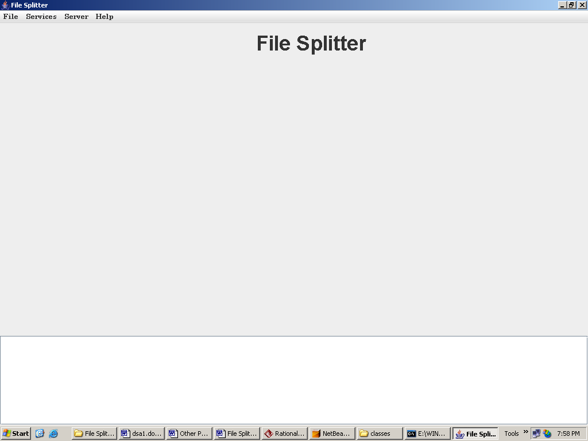

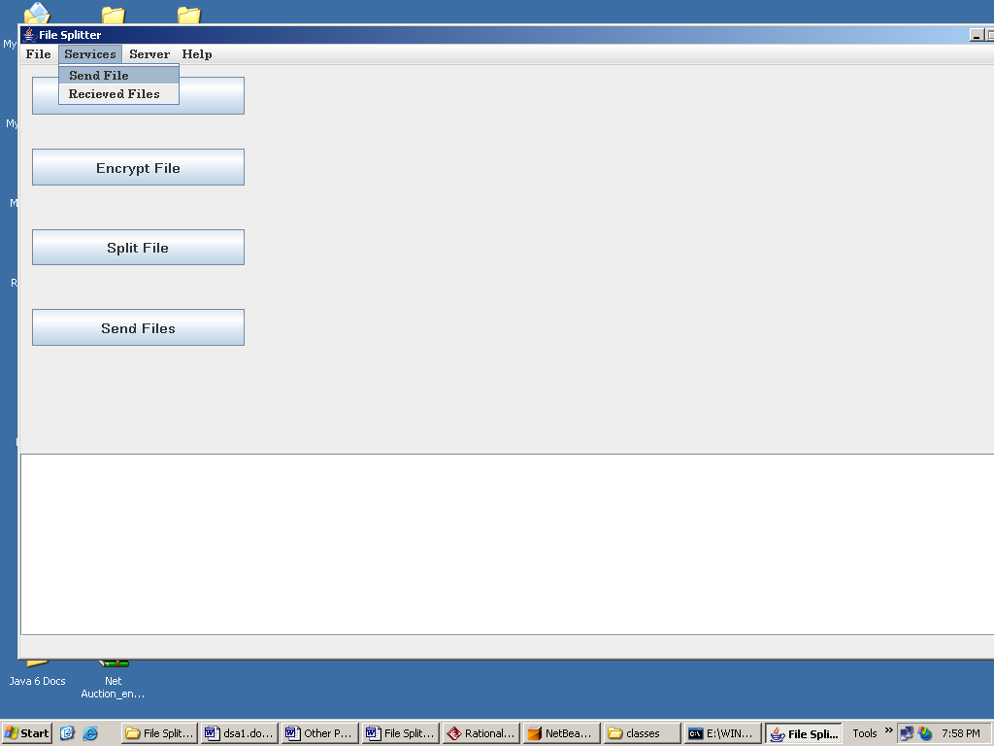

Select File:

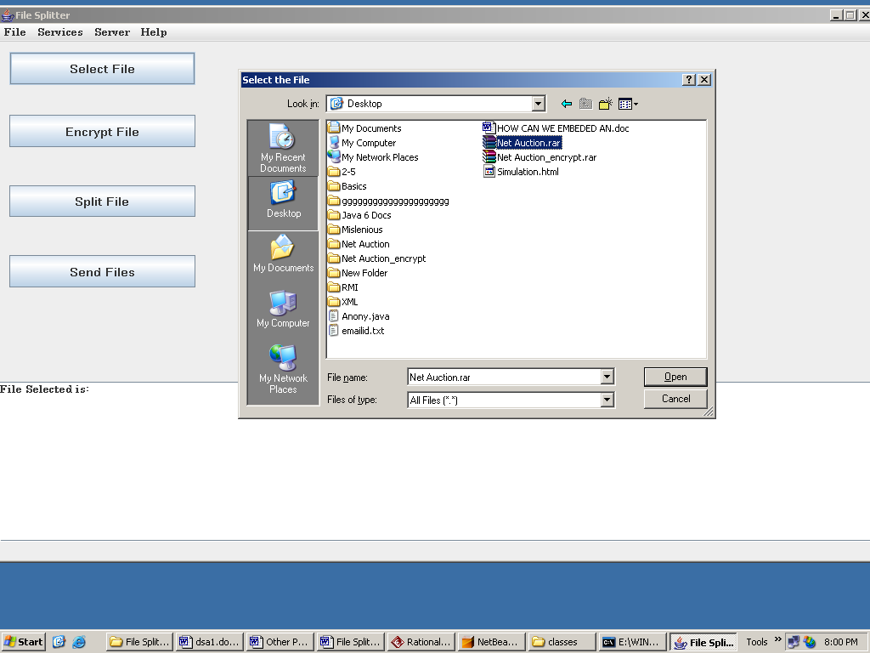

Encrypt File:

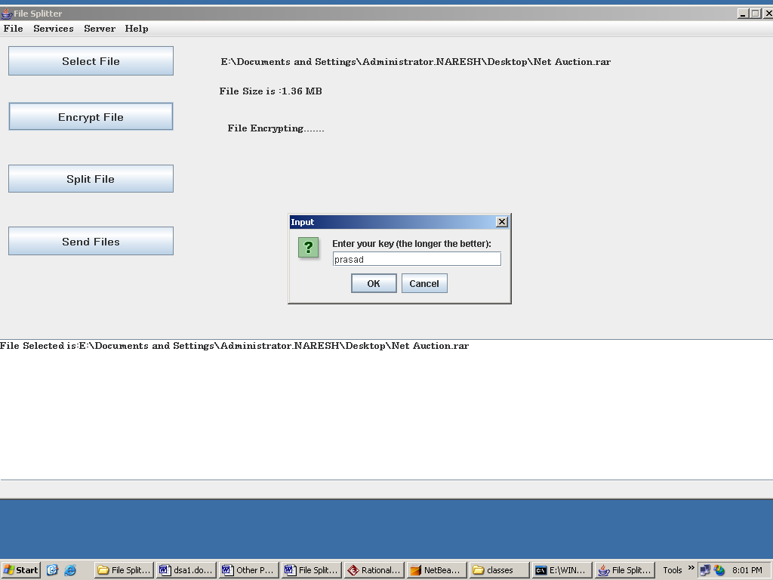

Save Encrypted File:

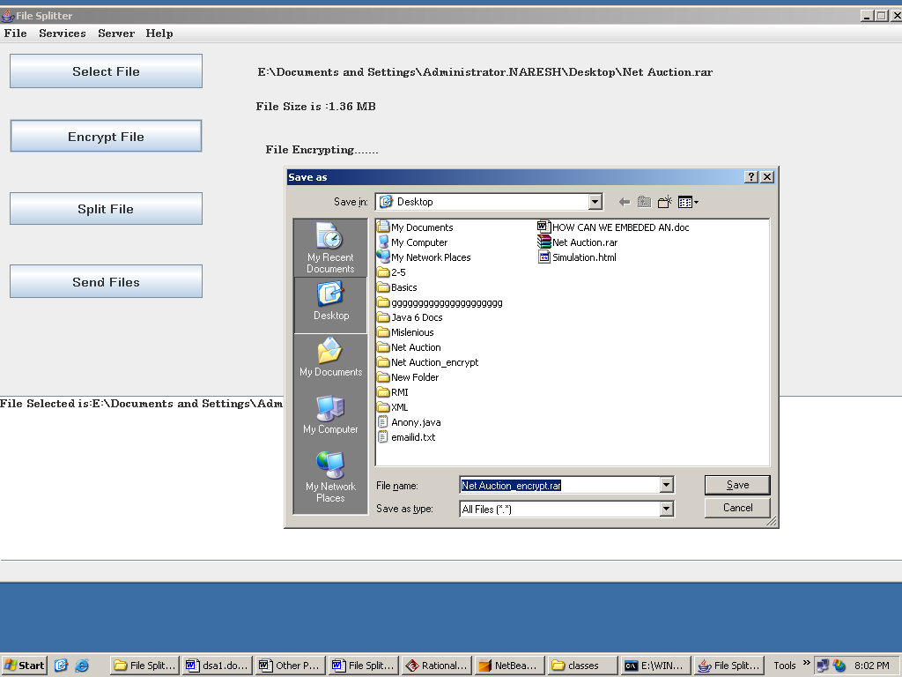

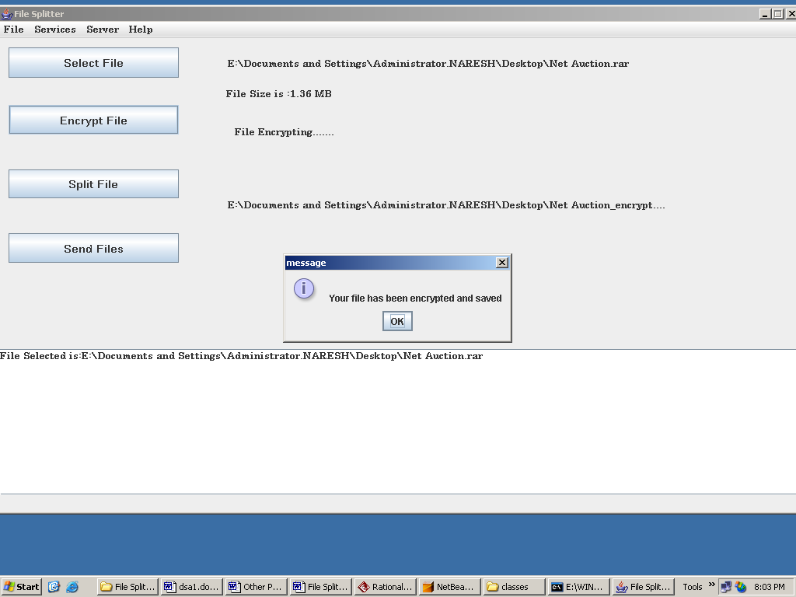

Split File:

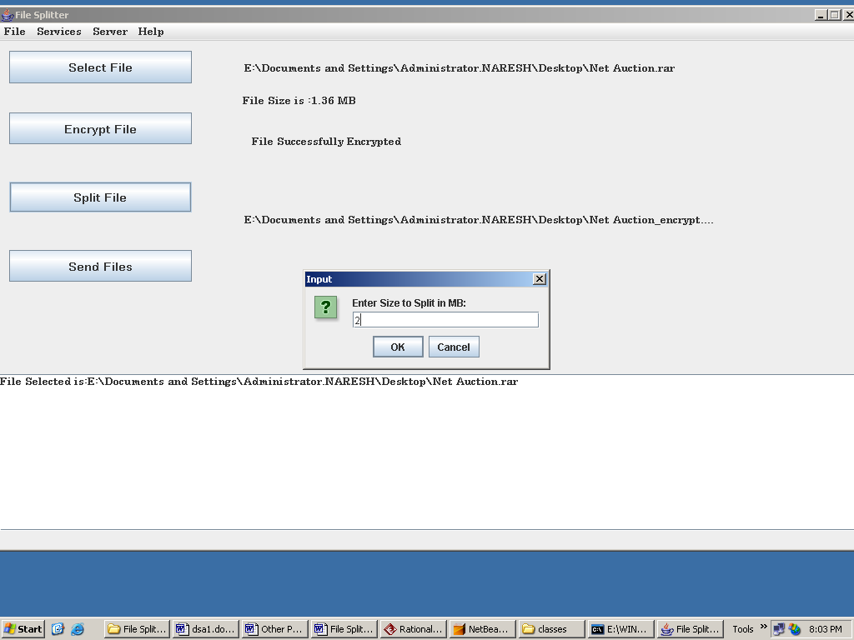

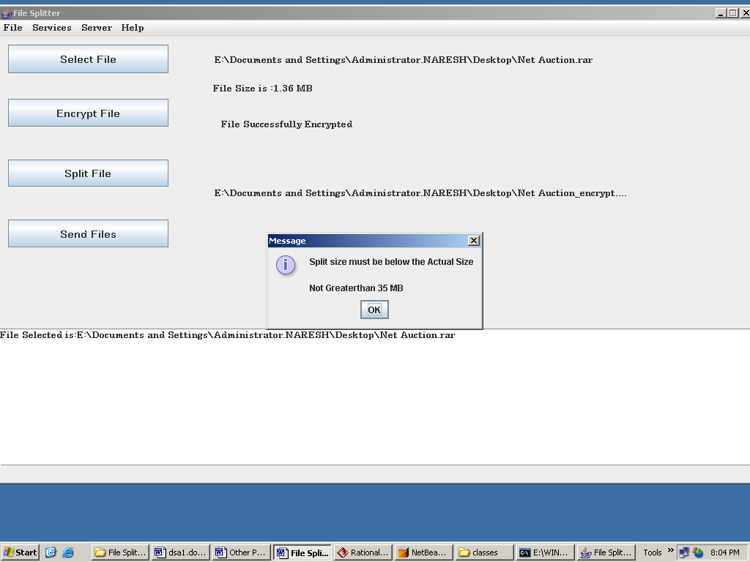

Select Encrypted File to split:

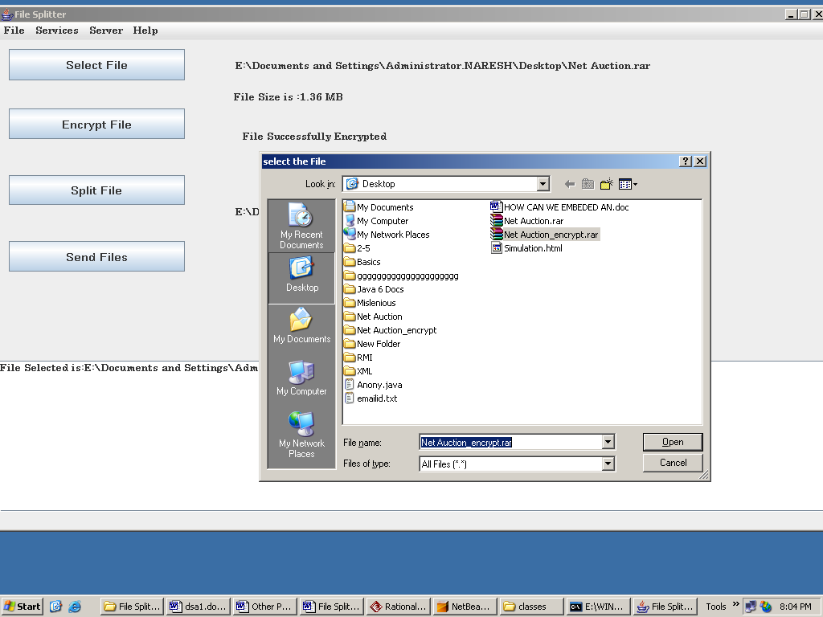

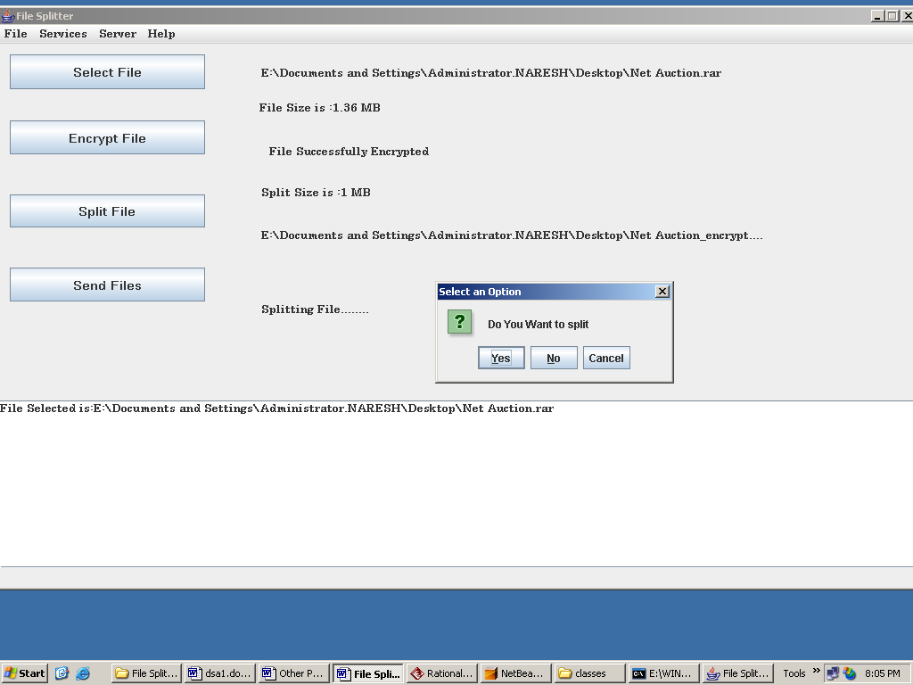

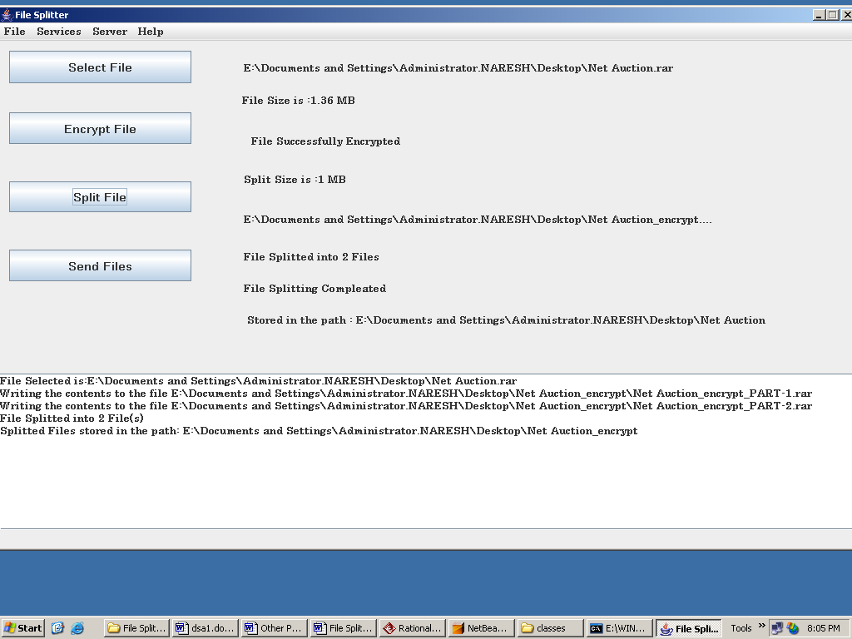

Sent Files:

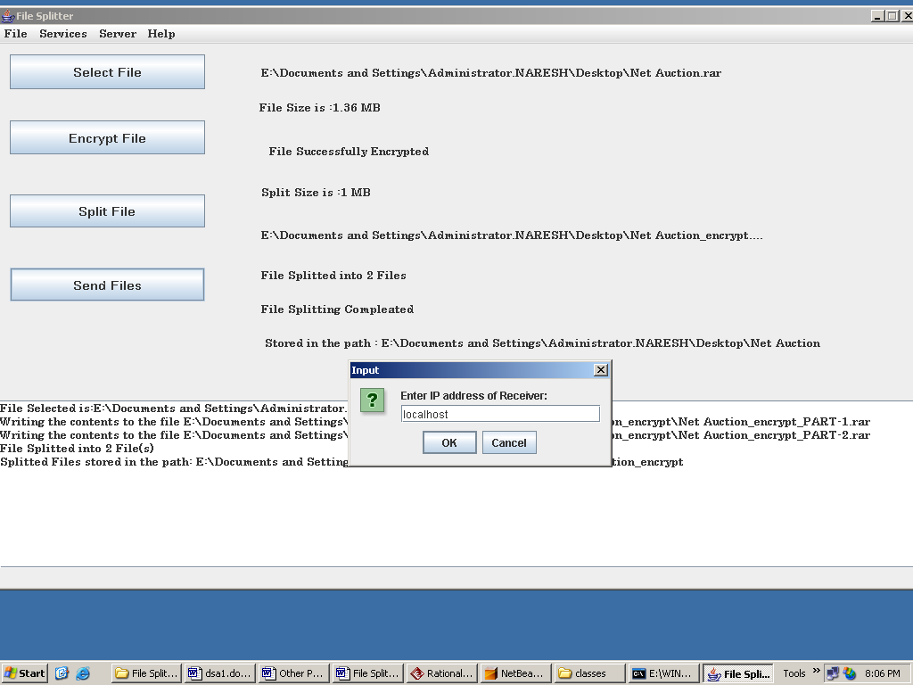

elect File To Send:

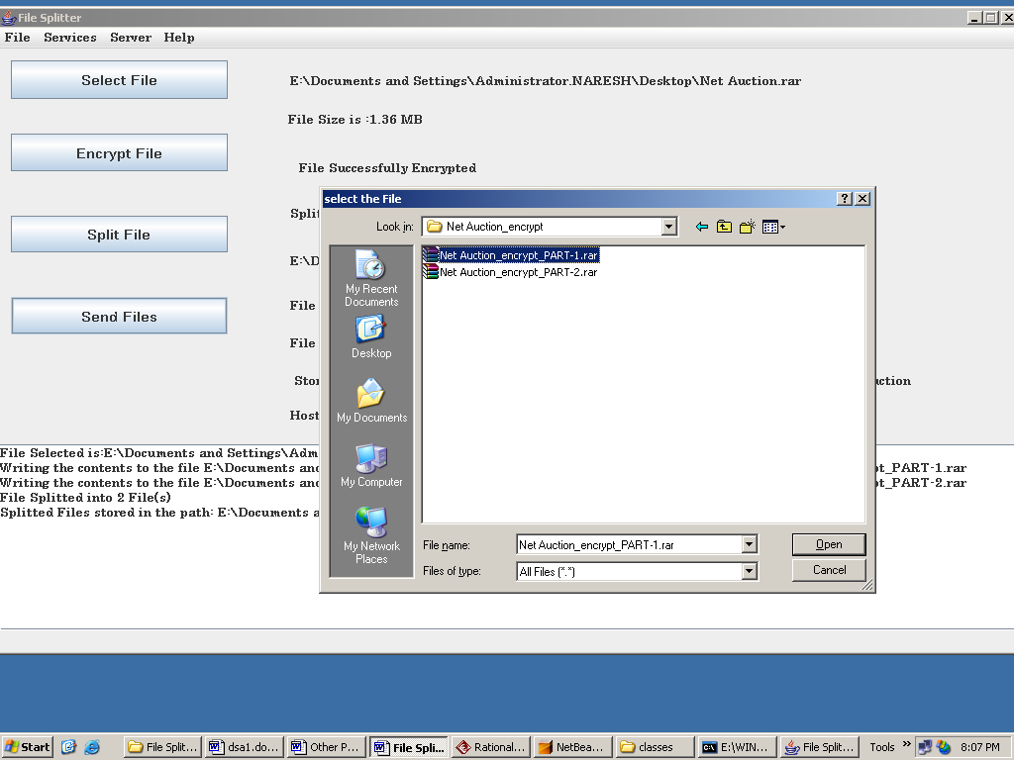

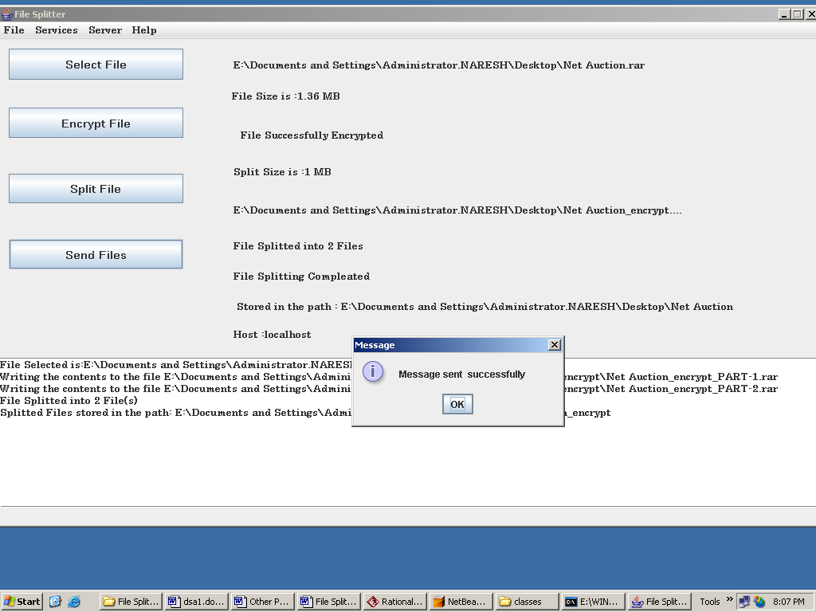

Receiver:

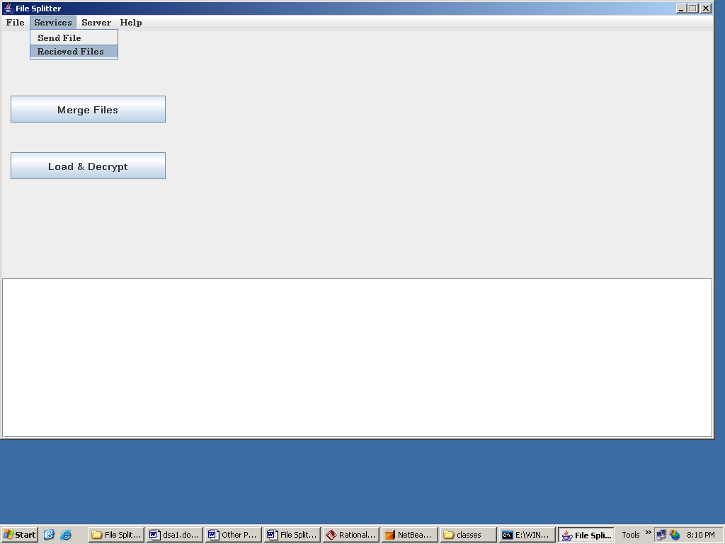

Select Directory to Merge:

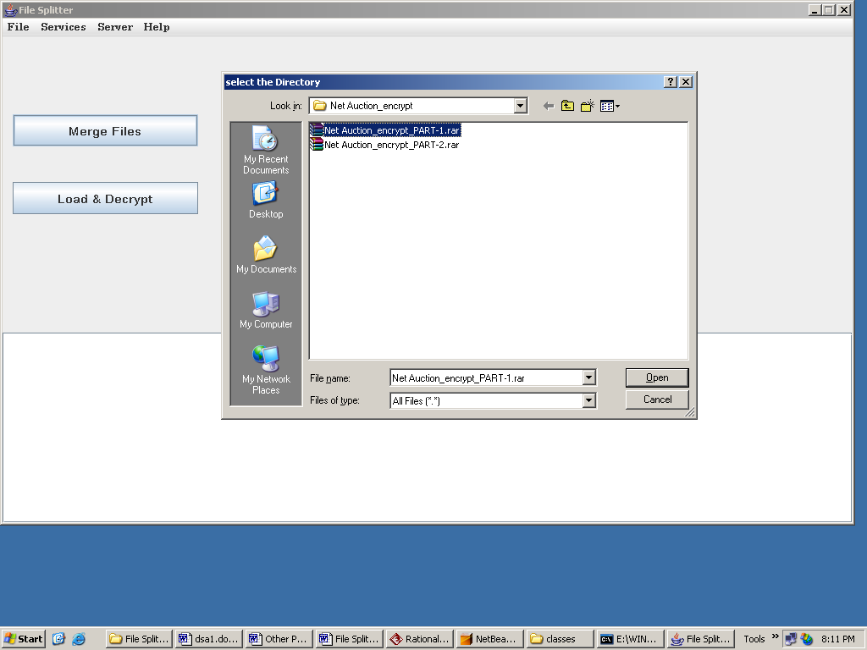

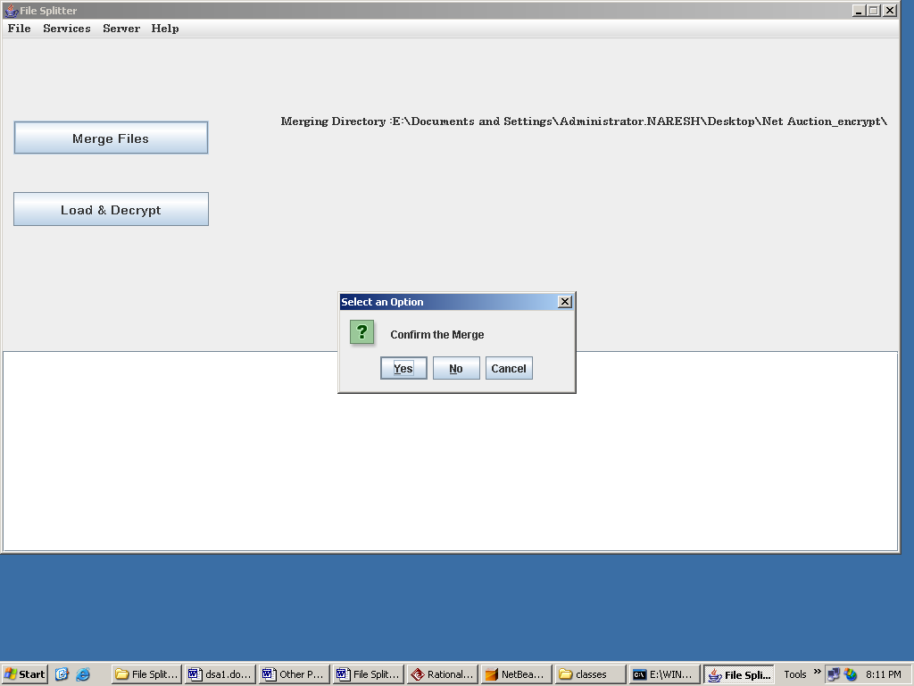

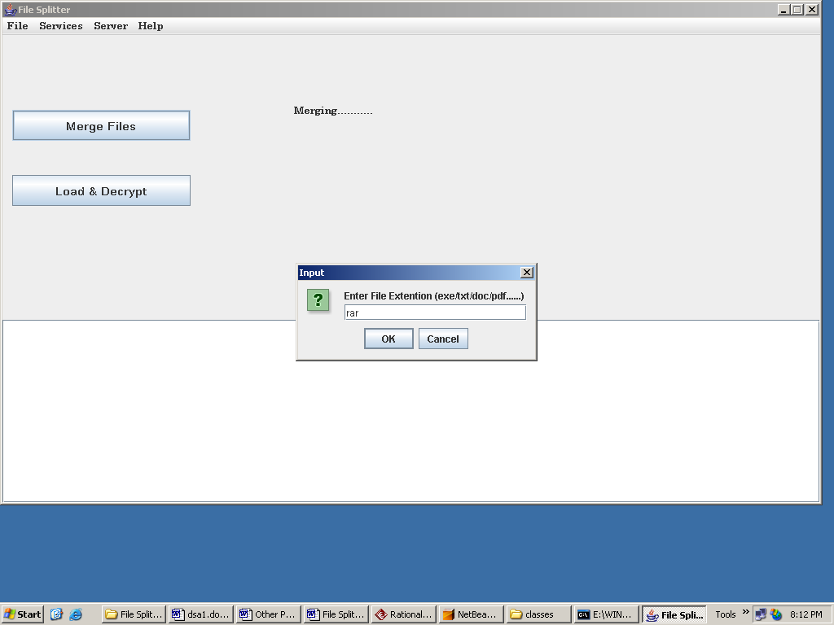

Load Merge File:

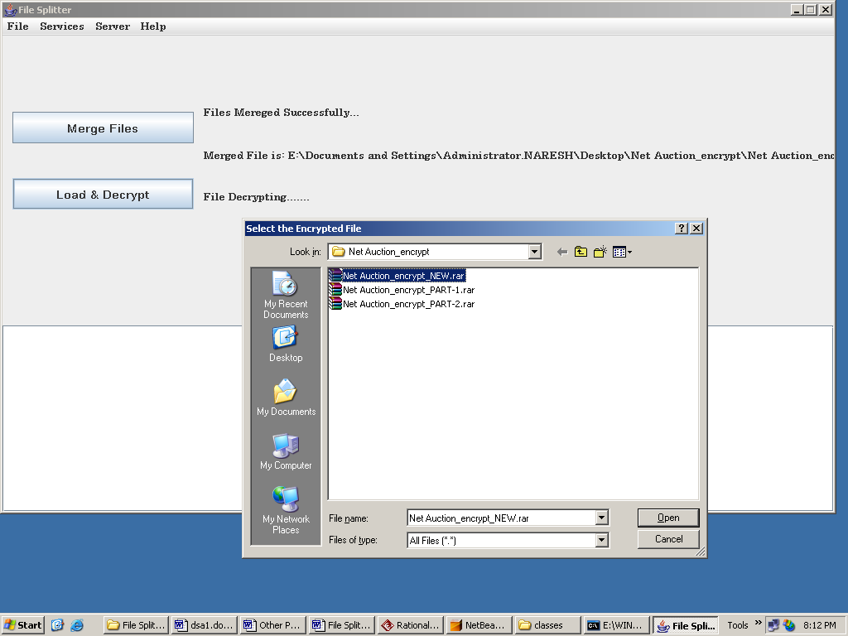

Decrypt:

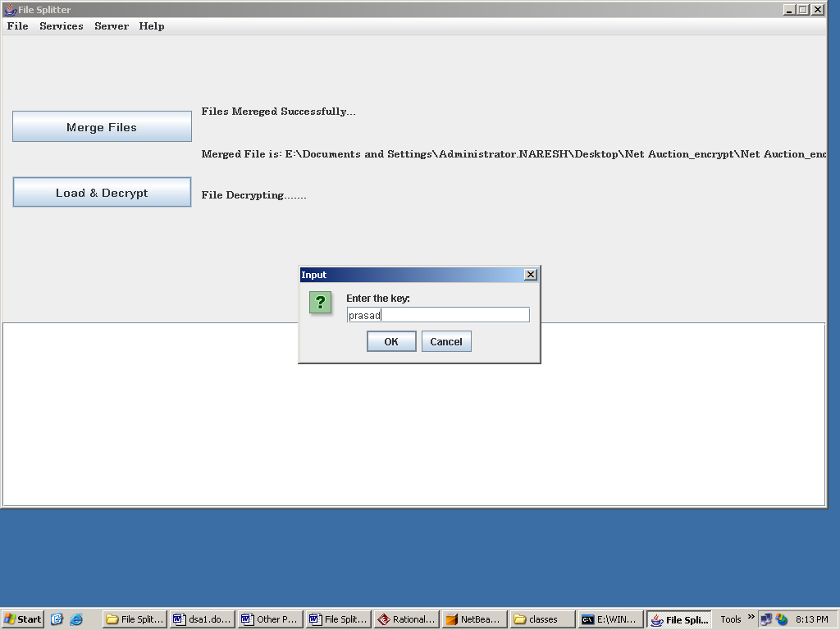

Save Decrypted File:

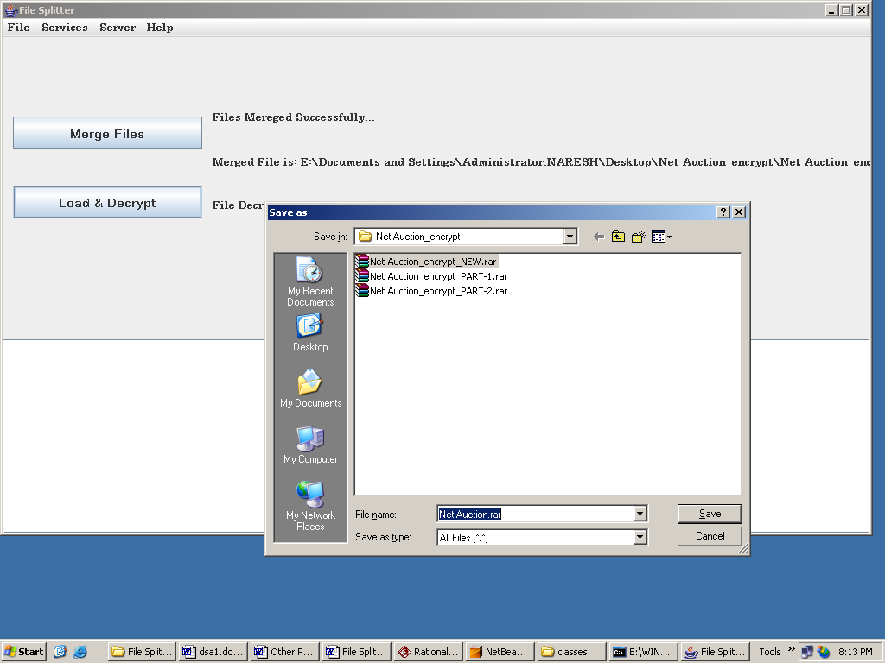

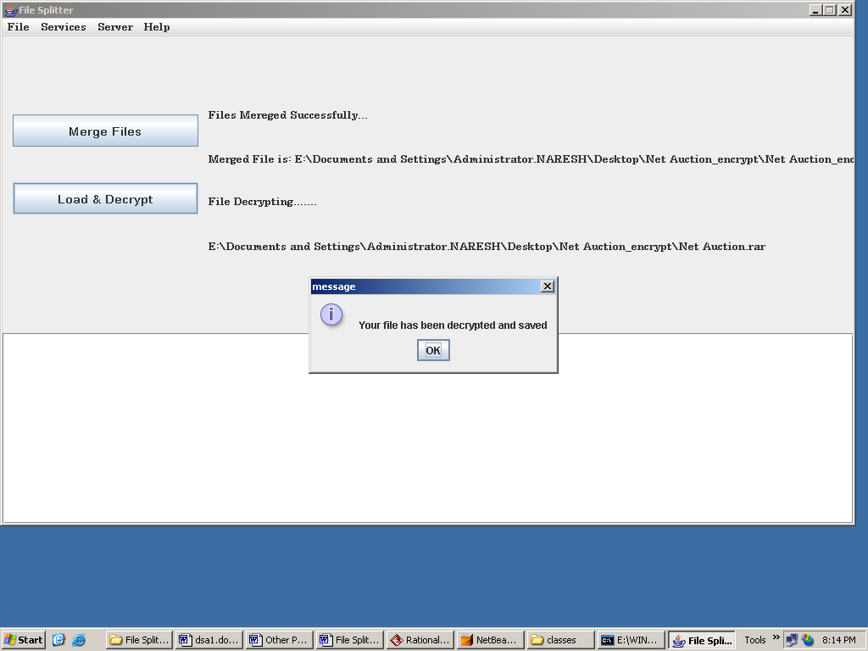

Help:

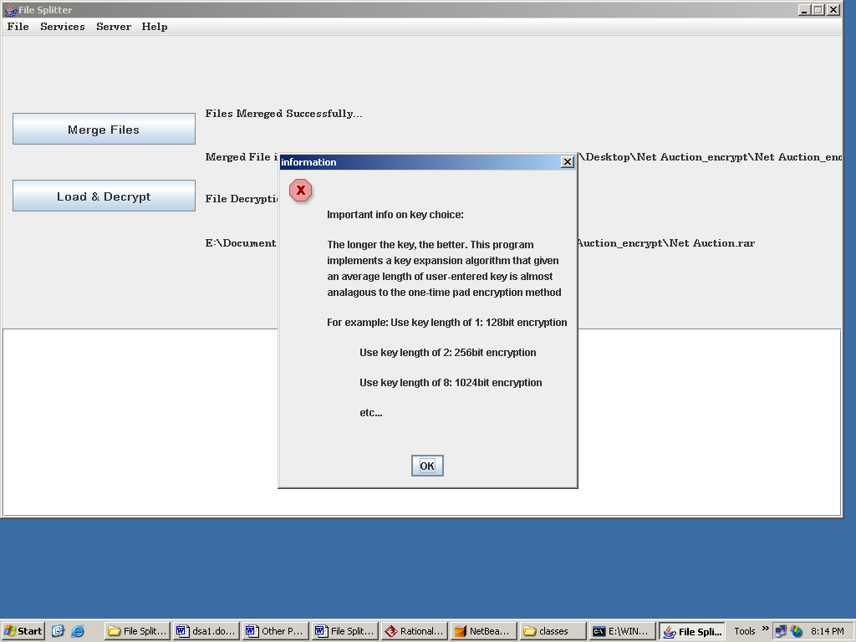

FUTURE ENHANCEMENTS

It is not possible to develop a system that makes all the requirements of the user. User requirements keep changing as the system is being used. Some of the future enhancements that can be done to this system are:
- As the technology emerges, it is possible to upgrade the system and can be adaptable to desired environment.
- Because it is based on object-oriented design, any further changes can be easily adaptable.
- Based on the future security issues, security can be improved using emerging technologies.

BIBLIOGRAPHY

REFERENCES
(1) Java Complete Reference by Herbert Shield
(2) Database Programming with JDBC and Java by George Reese
(3) Java and XML By Brett McLaughlin

(4) Wikipedia, URL: http://www.wikipedia.org.

(5) Answers.com, Online Dictionary, Encyclopedia and much more, URL: http://www.answers.com
(6) Google, URL: http://www.google.co.in
(7)Project Management URL: http://www.startwright.com/project.htm
(8) http://it.toolbLox.com/wiki/index.php/Warehouse_Management

